**TO CONNECT CLOUDSHELL**

Click on the **CloudShell** icon in the top-right corner (next to the search bar) 🡪 **Wait for the terminal to load**: A Linux-based shell will open with pre-installed AWS CLI and development tools.

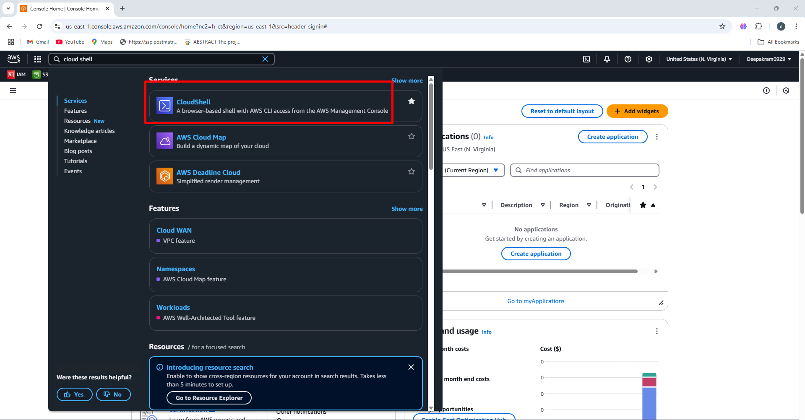

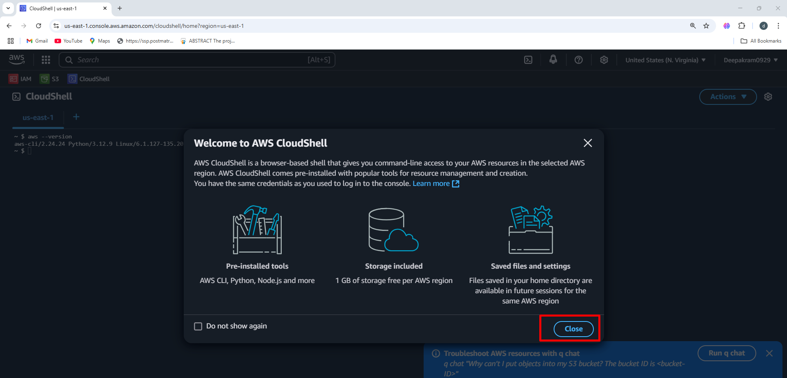

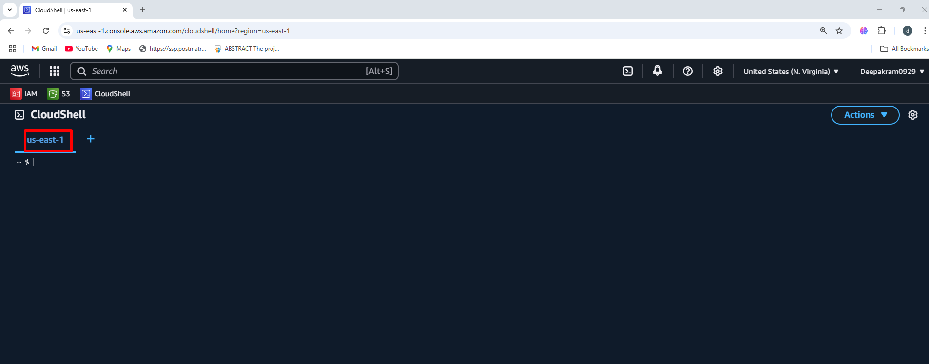

**TO LAUNCH EC2 INSTANCE WITH NAME USING CLOUD SHELL**

**Commands:**

aws ec2 run-instances --image ami-08b5b3a93ed654d19 --instance-type t2.micro --key-name aws-key-0929 --security-group-ids sg-0e9b2e625f5c3168d \

--tag-specifications 'ResourceType=instance,Tags=[{Key=Name,Value=win-ser-1}]'

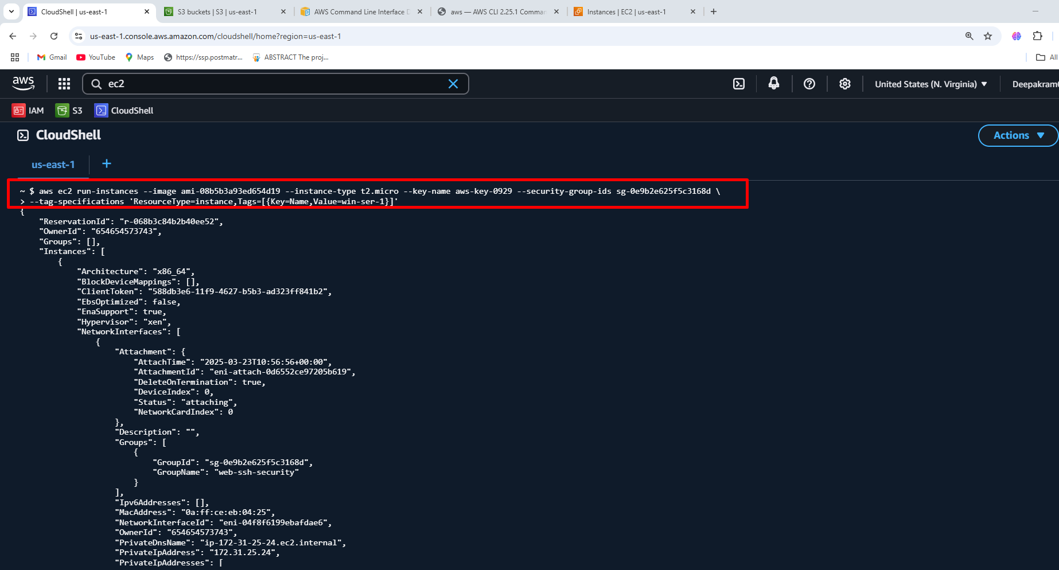

**After connect manually to virtual server using RDP client**

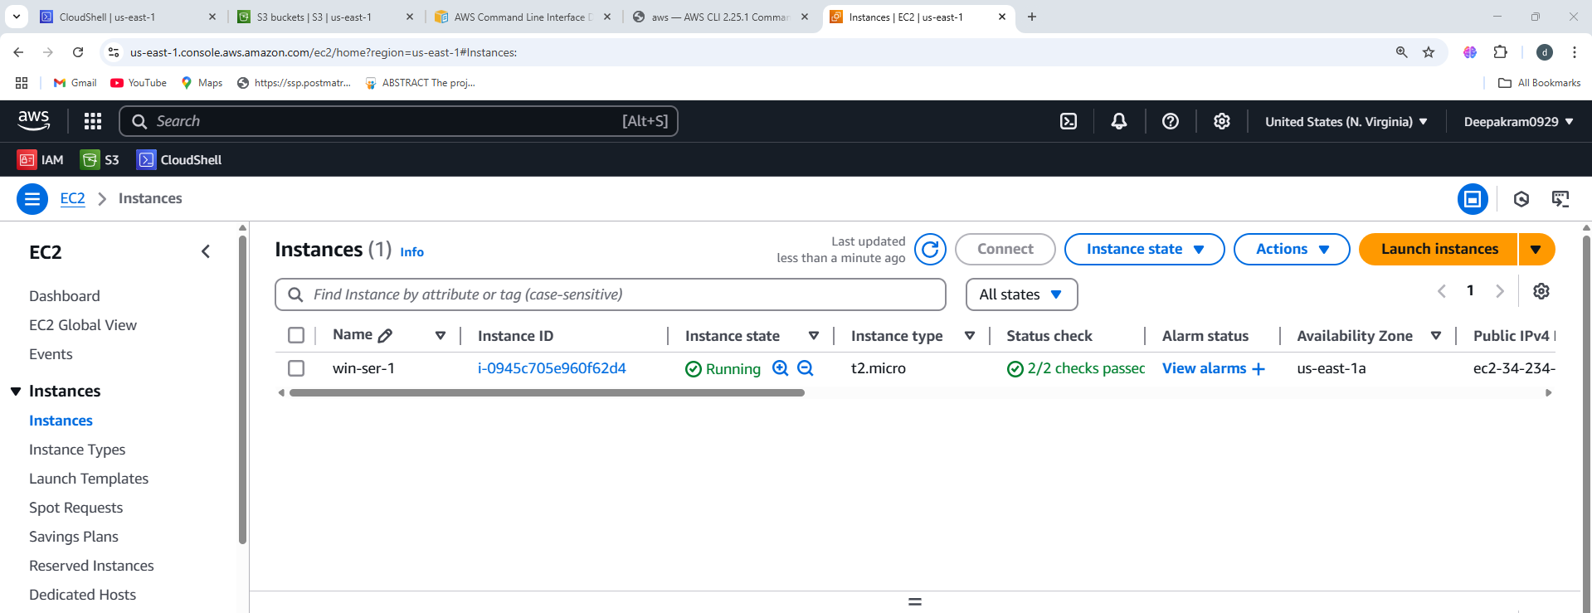

**TO LAUNCH EC2 INSTANCE WITH USER-DATA AND SPECIFIC AVAILABILITY ZONE**

aws ec2 run-instances --image ami-08b5b3a93ed654d19 --instance-type t2.micro --key-name aws-key-0929 --security-group-ids sg-0e9b2e625f5c3168d --subnet-id subnet-01ecf0594e28947df \

--tag-specifications 'ResourceType=instance,Tags=[{Key=Name,Value=user-data}]' --user-data file://user-data.txt

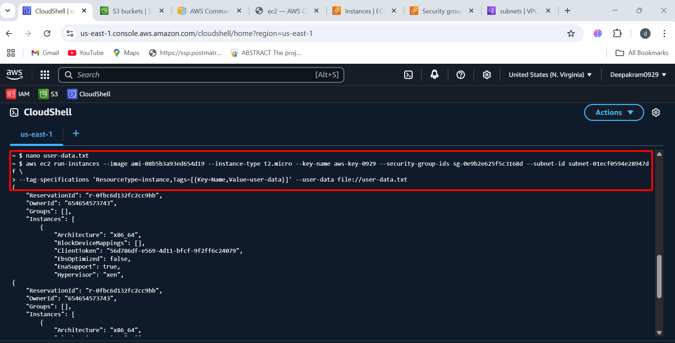

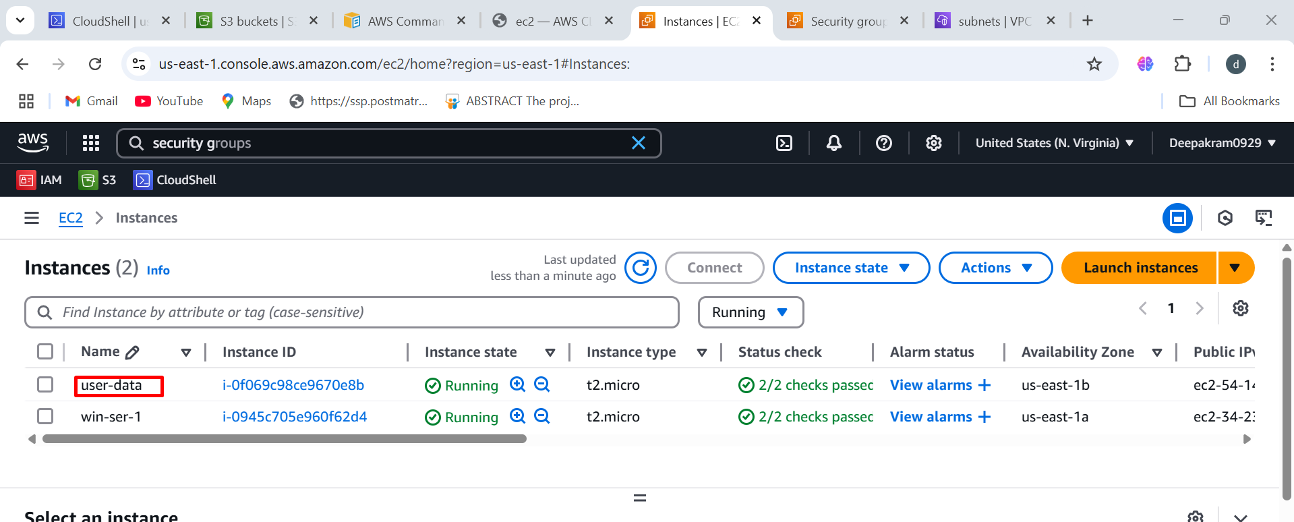

**Login to ec2 console to check download or status of httpd**

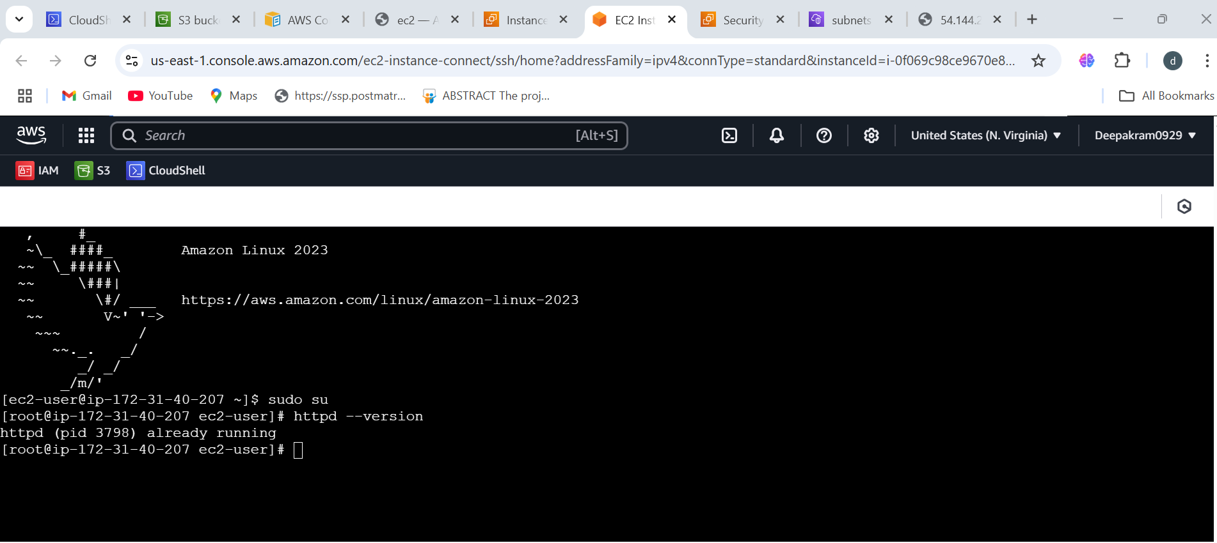

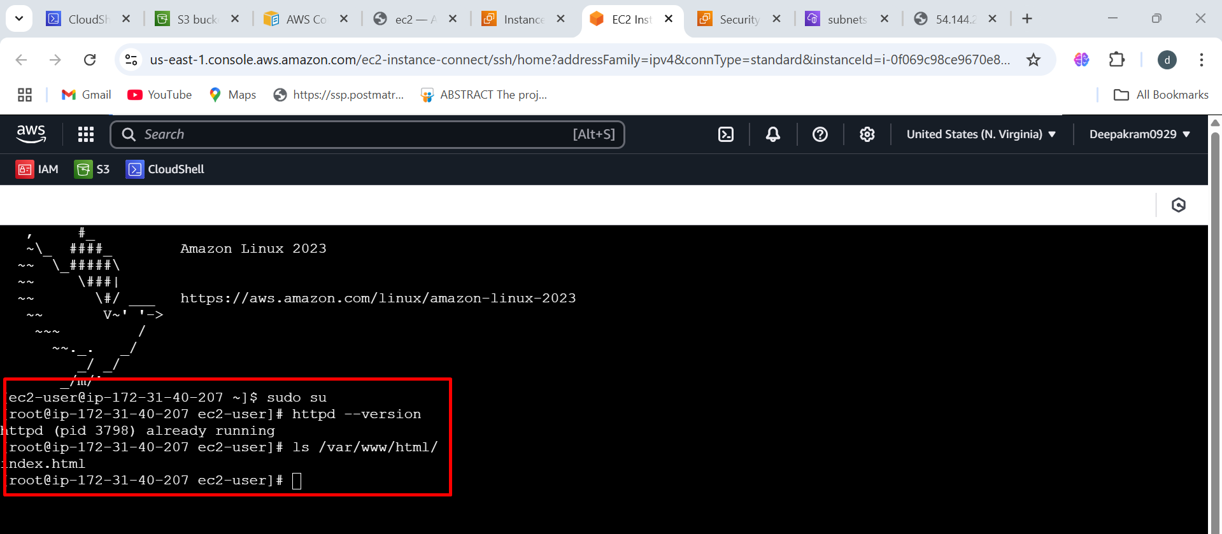

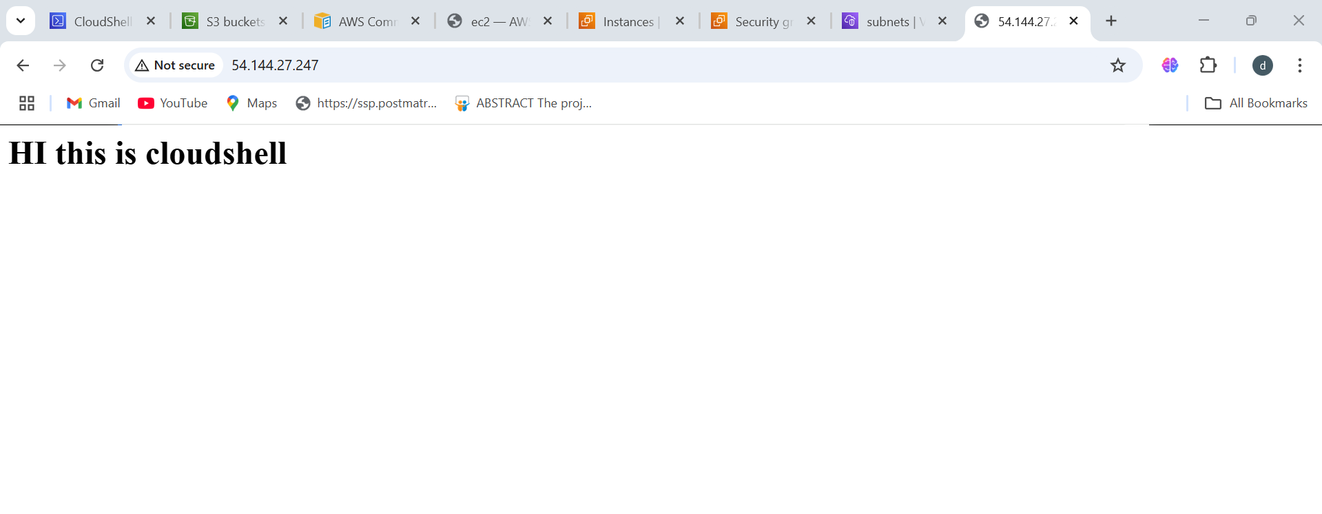

**TO LAUNCH EC2 INSTANCE WITH USER-DATA ,SUBNET, IAM-ROLE, COUNT**

aws ec2 run-instances --image ami-08b5b3a93ed654d19 --instance-type t2.micro --key-name aws-key-0929 --security-group-ids sg-0e9b2e625f5c3168d --subnet-id subnet-01ecf0594e28947df \

--tag-specifications 'ResourceType=instance,Tags=[{Key=Name,Value=web-application}]' --user-data file://user-data.txt \

--iam-instance-profile Name=ec2-s3-full-access --count 3

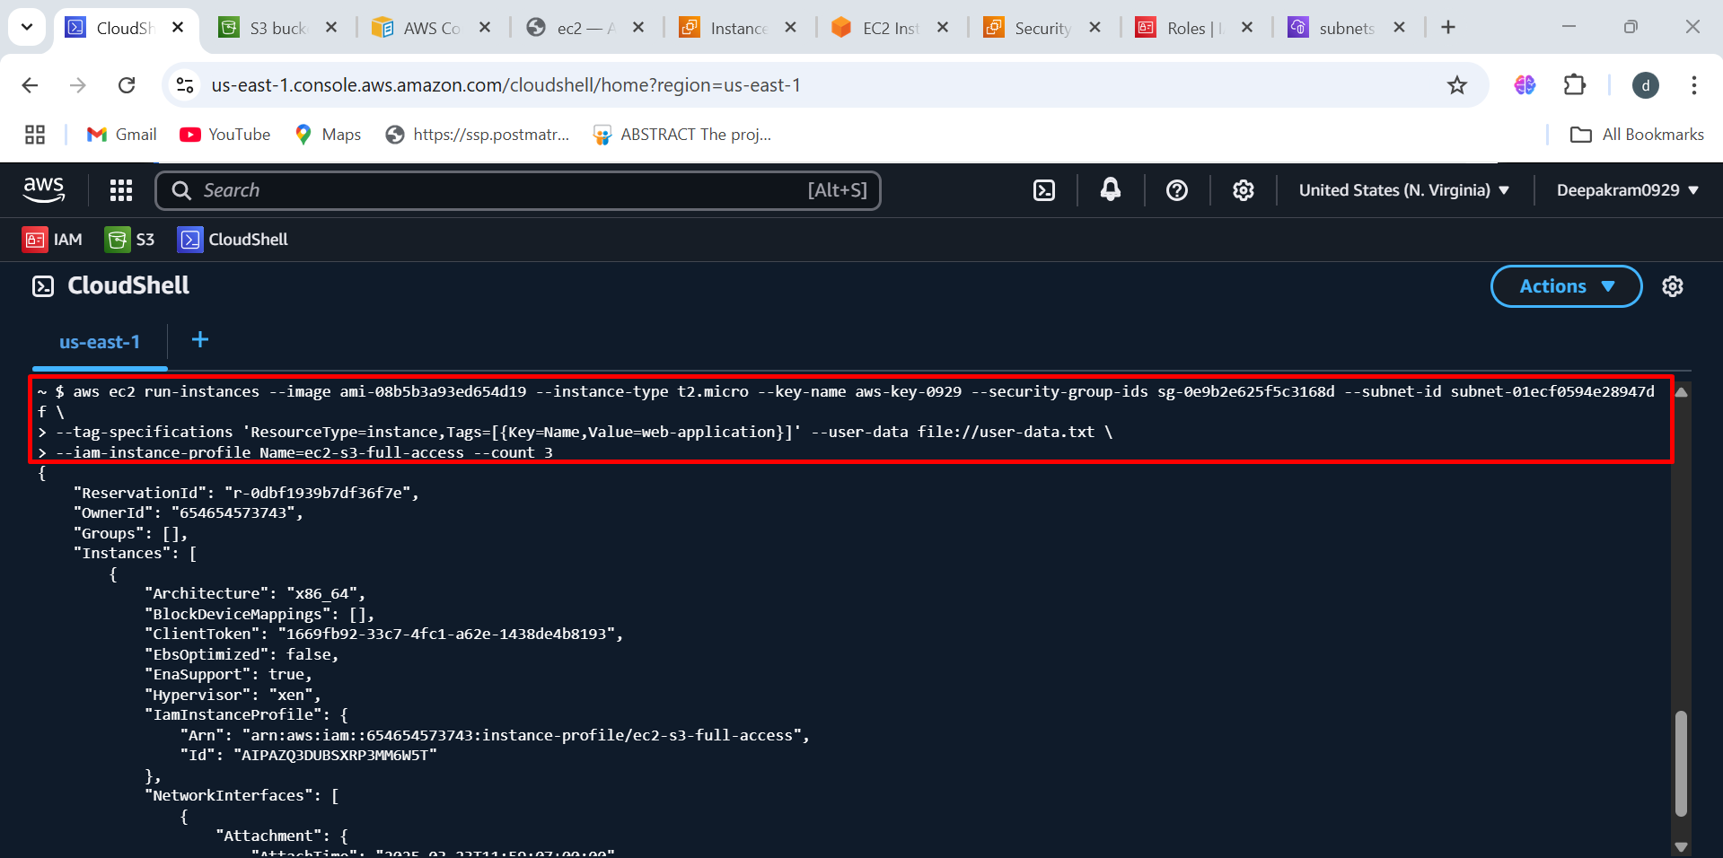

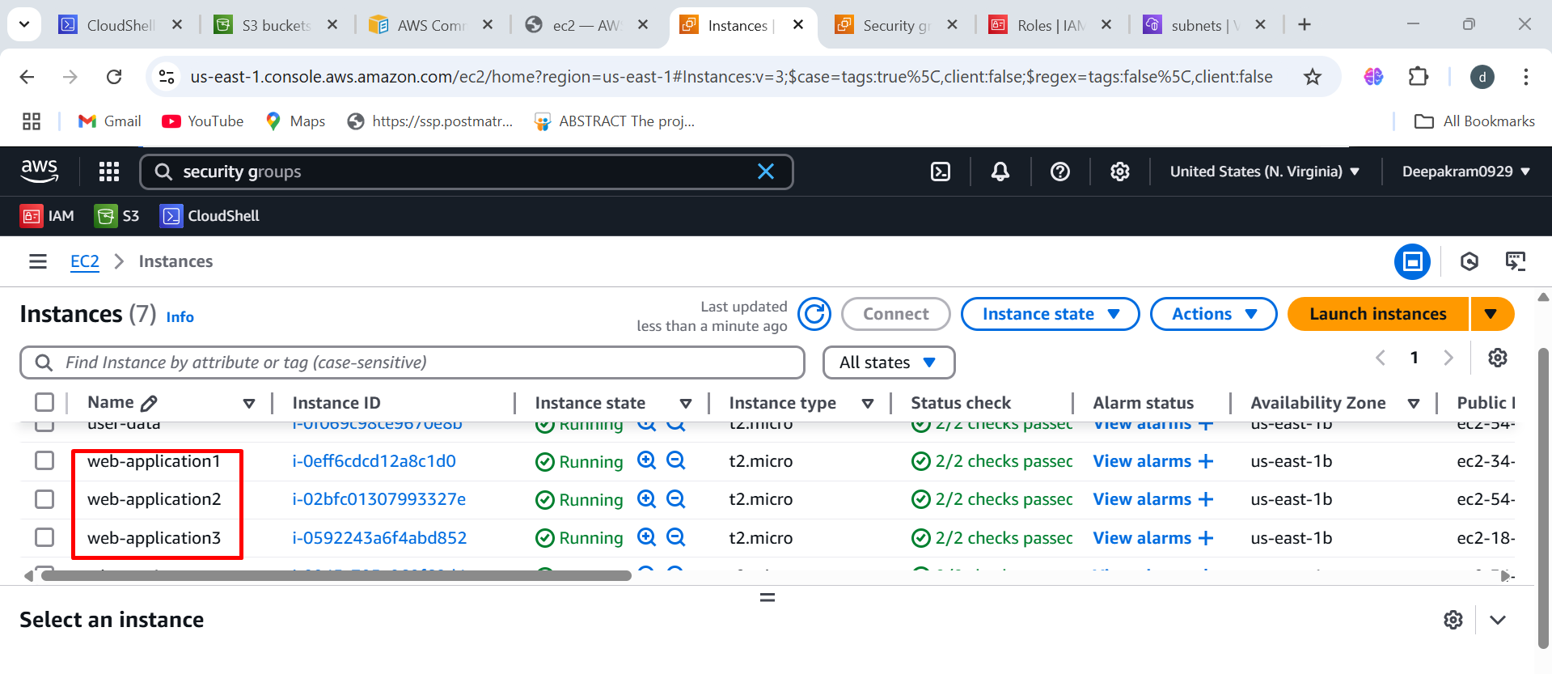

**To check IAM role and user-data present or not**

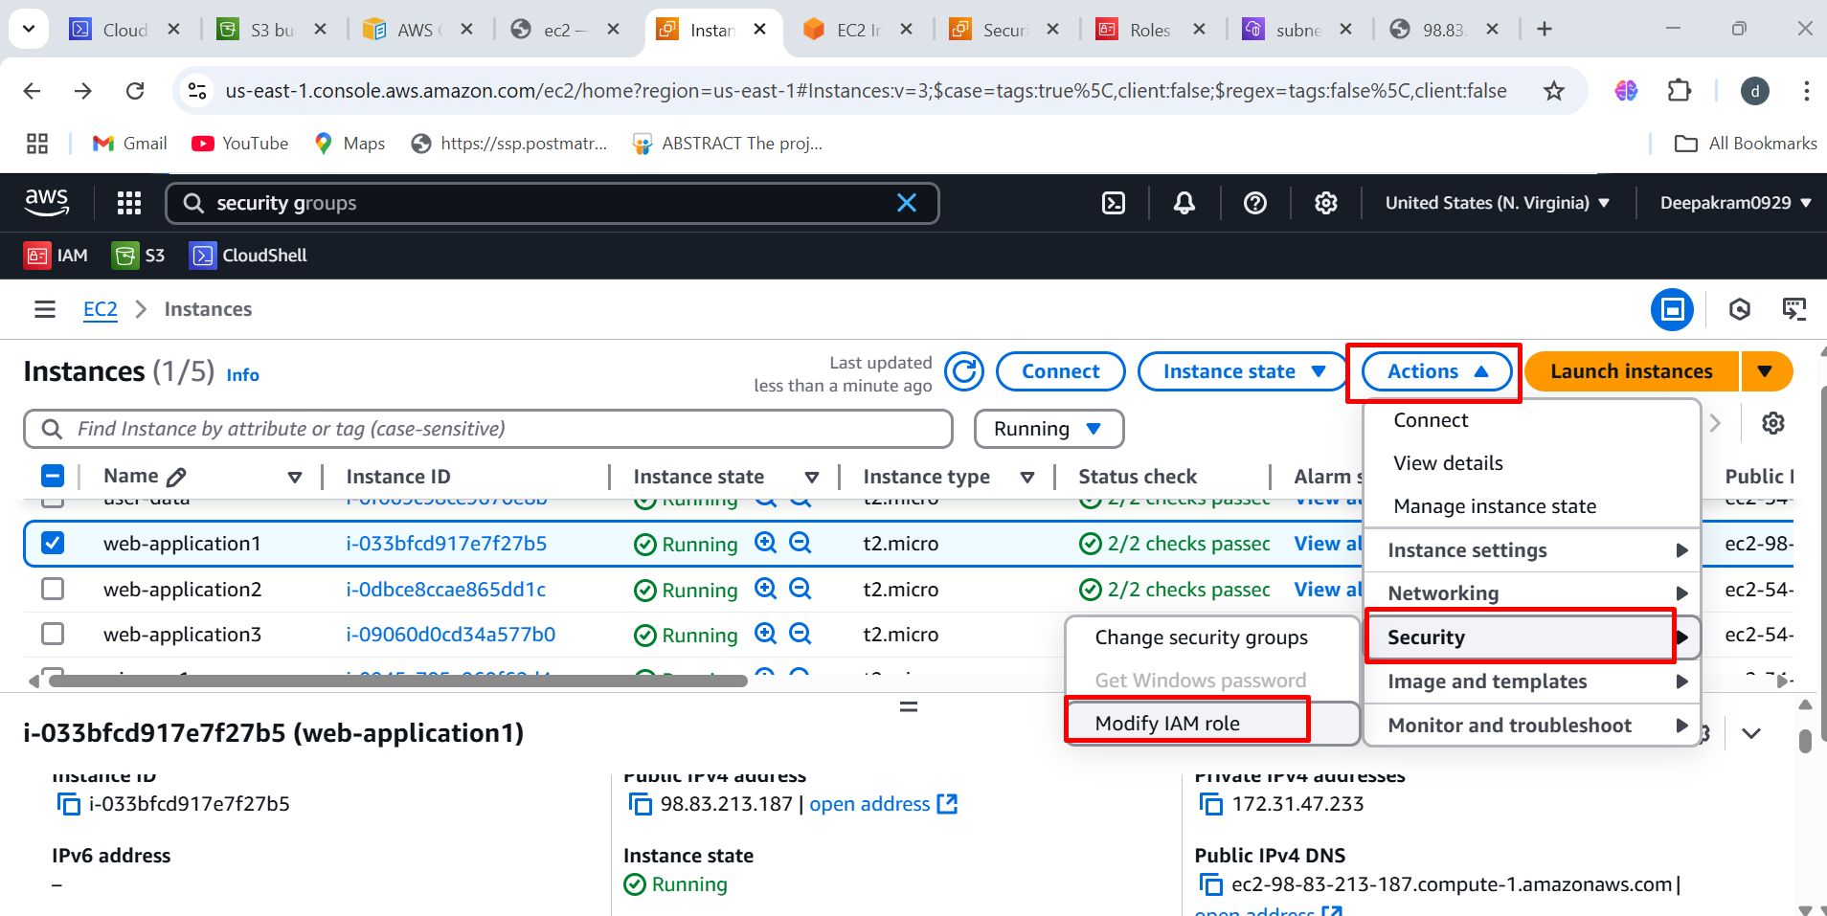

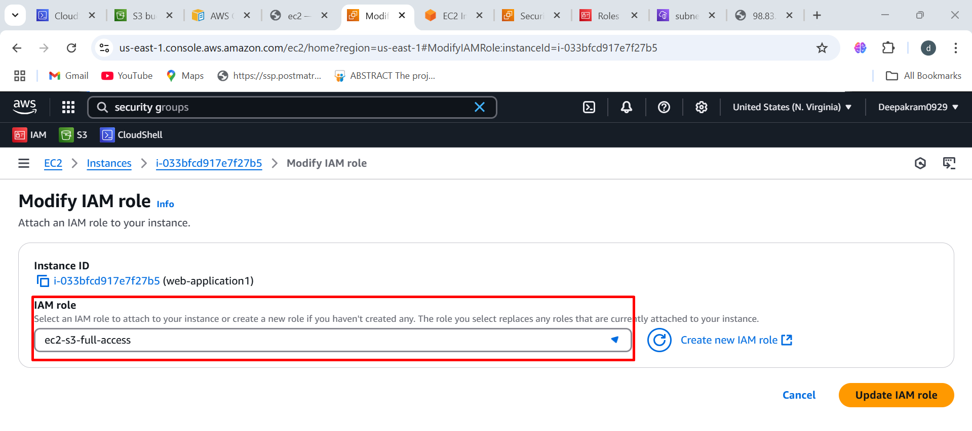

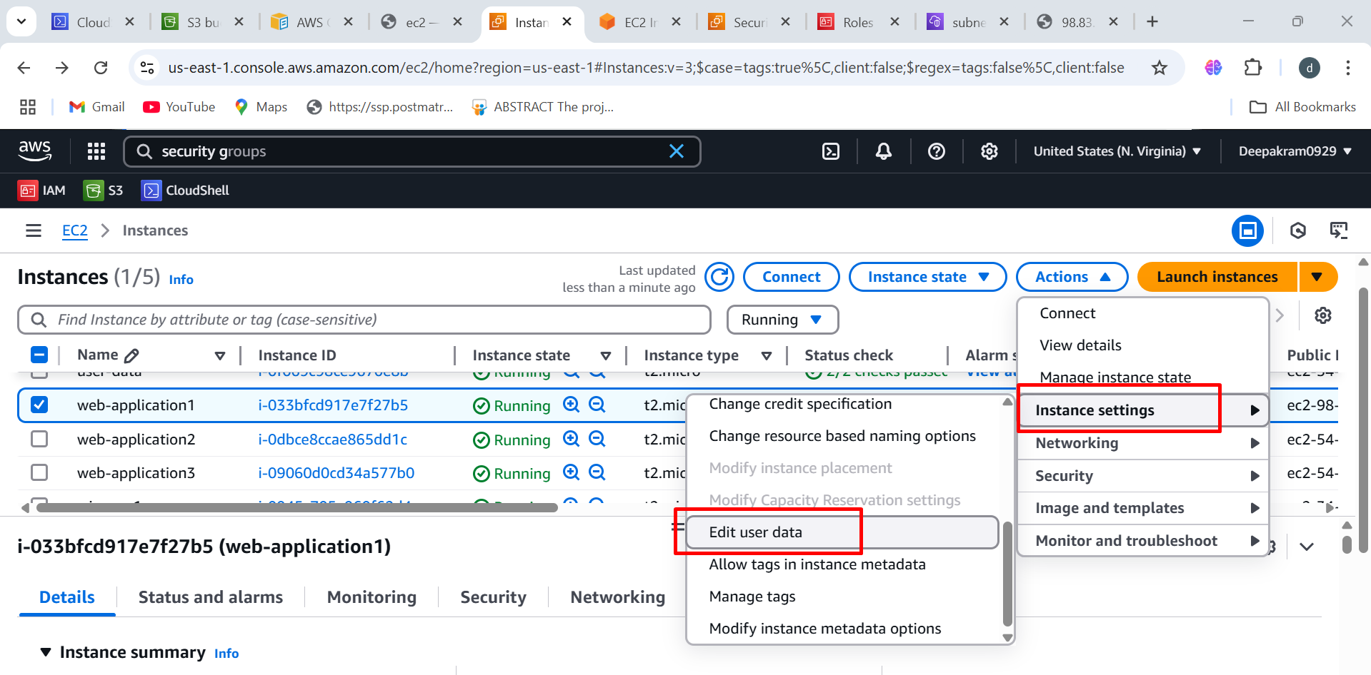

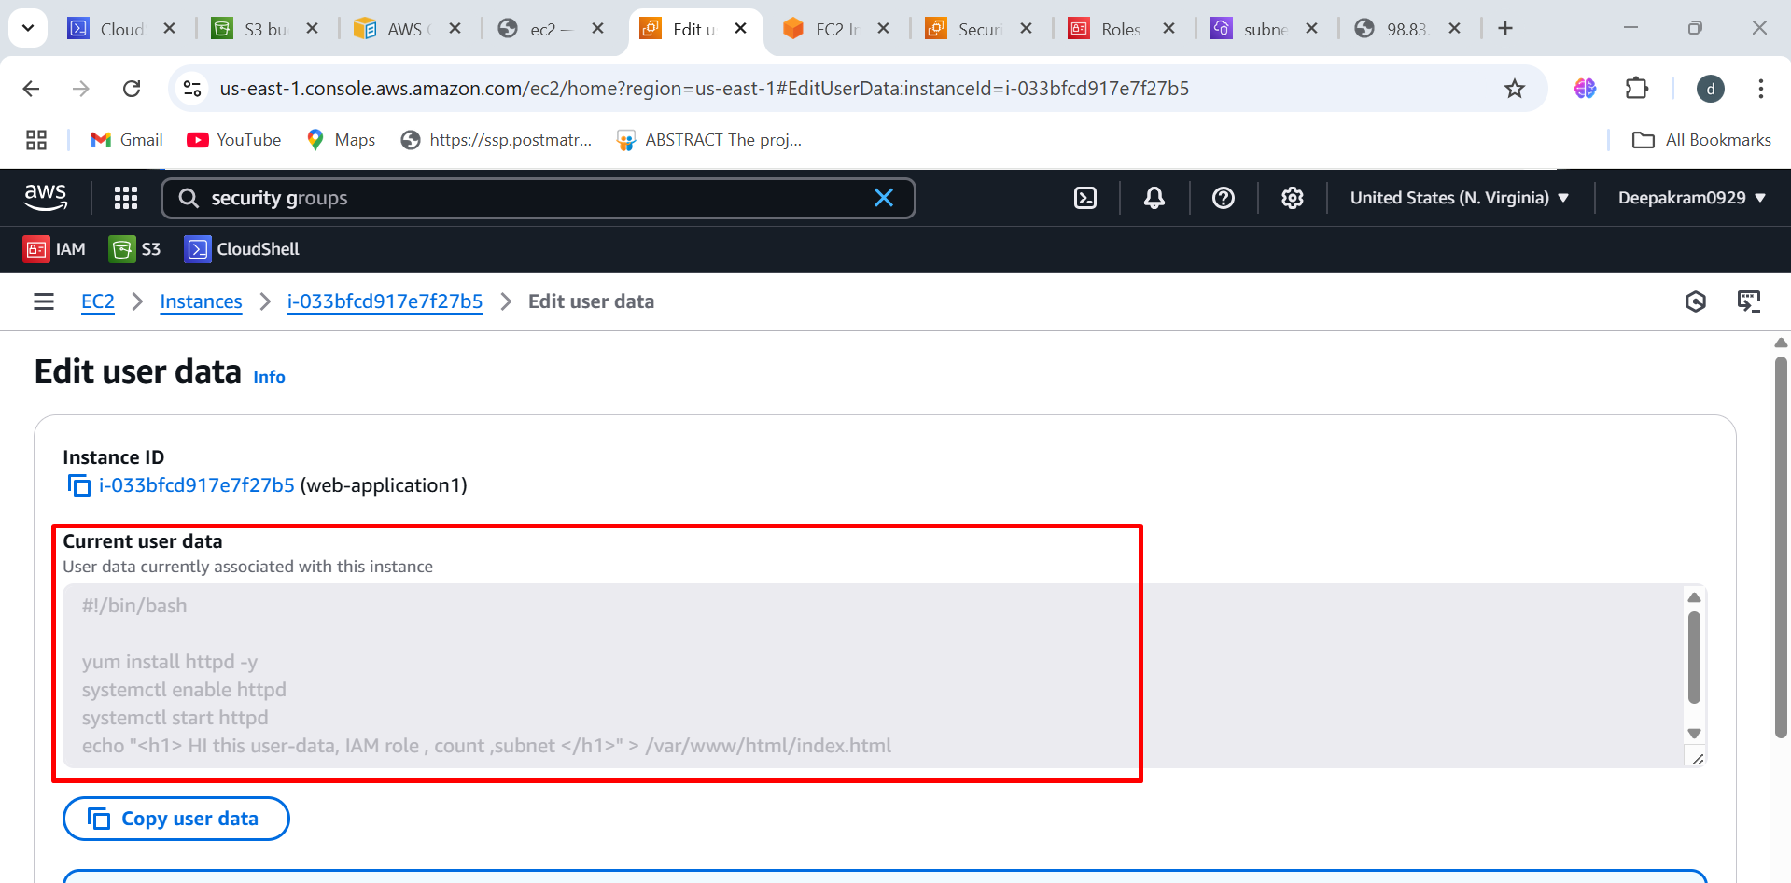

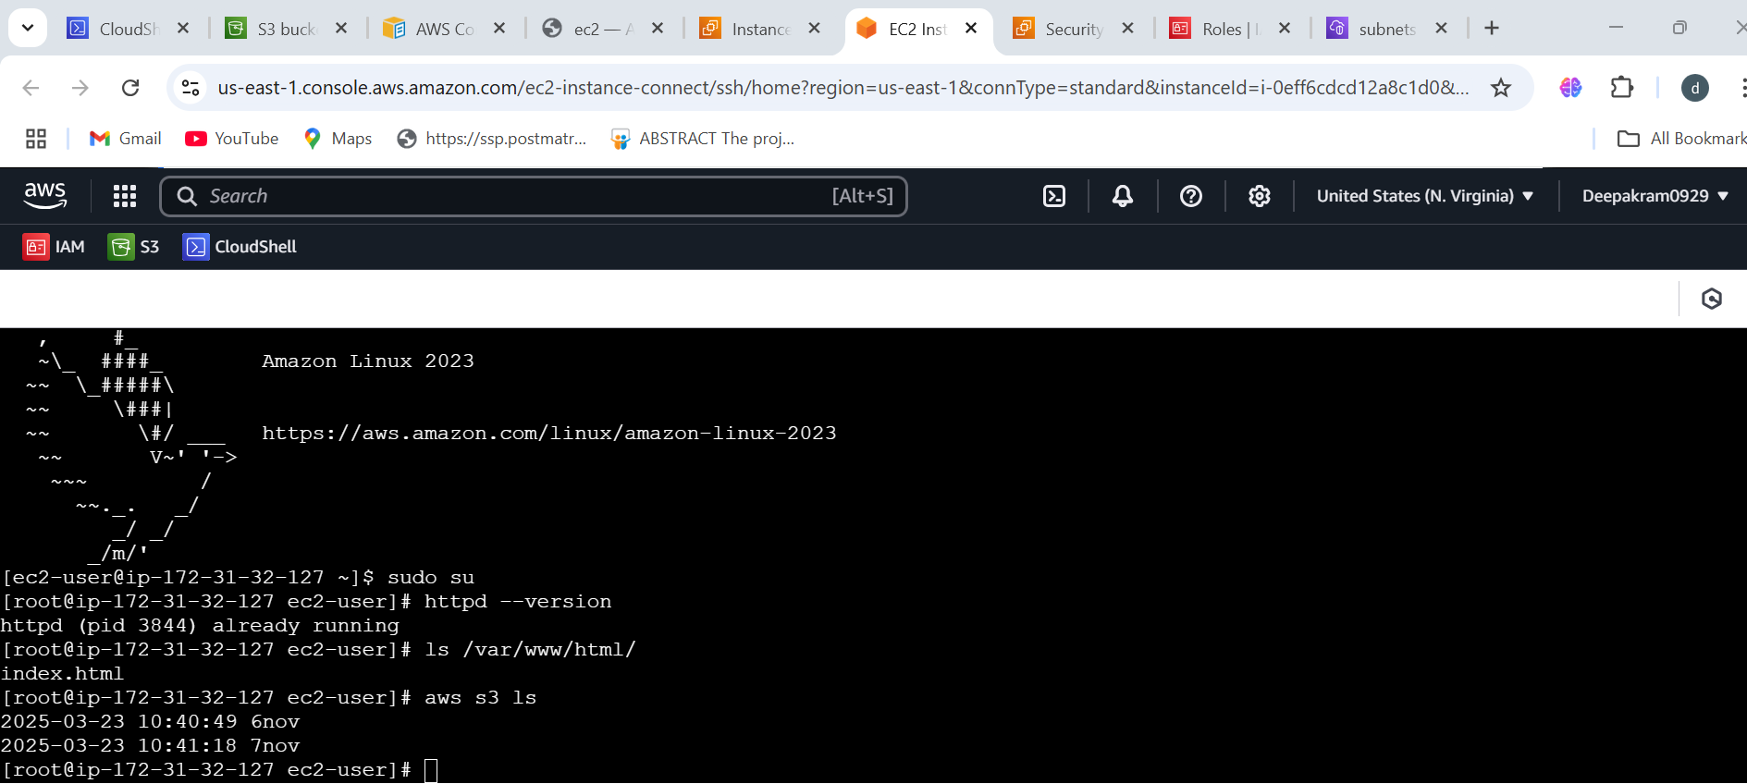

**Output of the web-application1 instance**

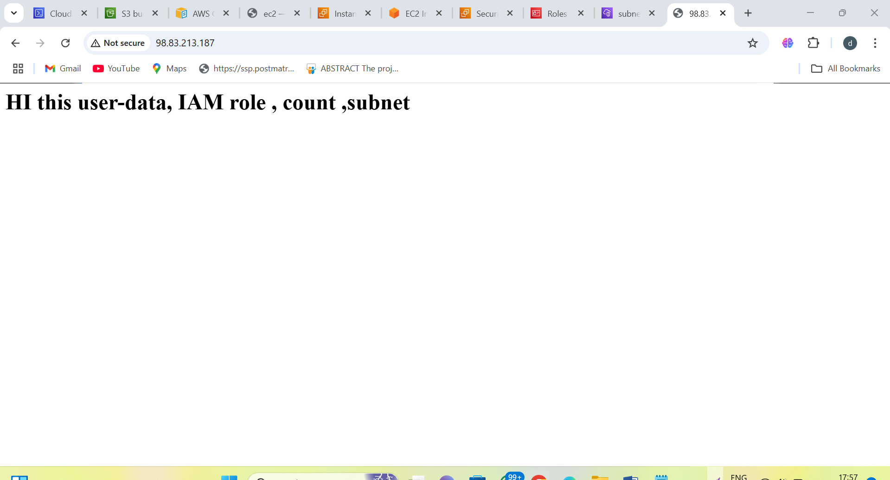

**CREATING EBS VOLUME**

aws ec2 create-volume --size 5 --availability-zone us-east-1b

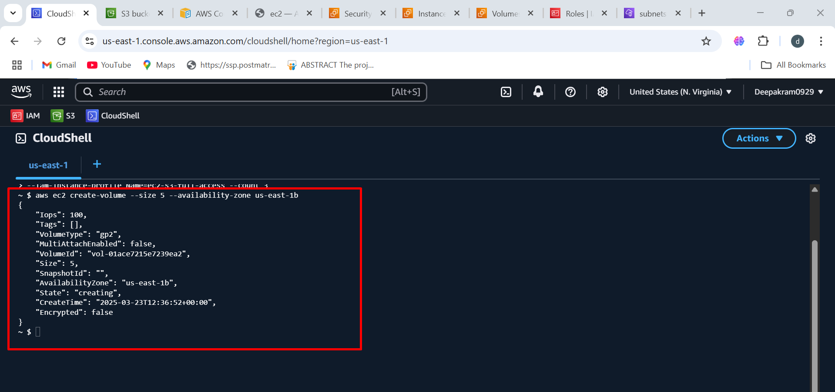

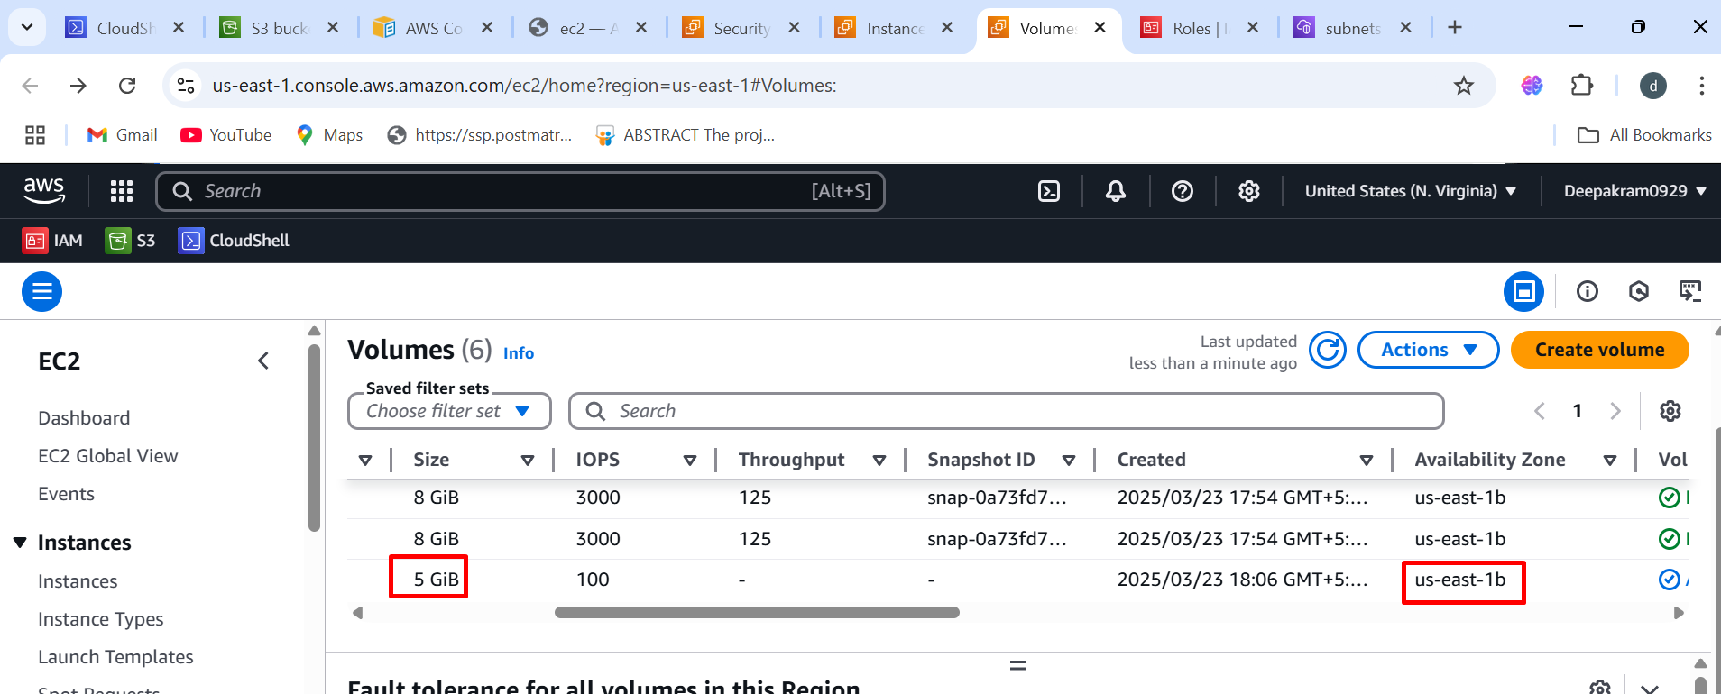

**Attached 5gb volume to web-application-1**

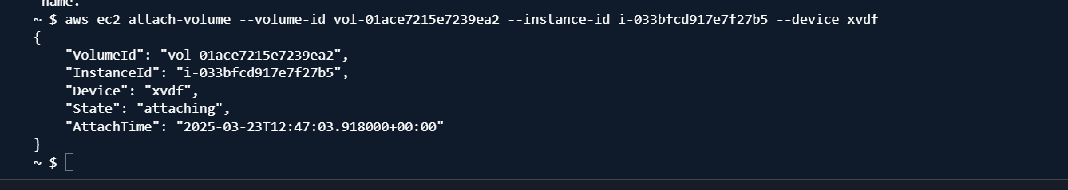

**The lsblk command is used to list information about block devices (disks, partitions, etc.) in a Linux**

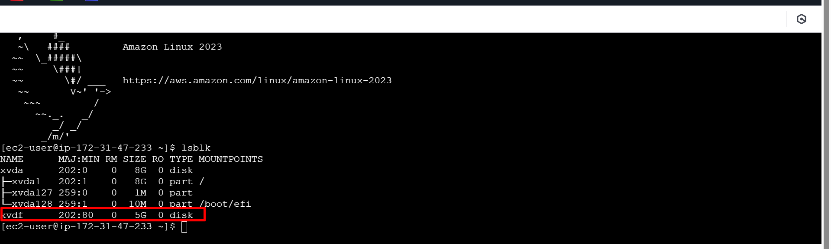

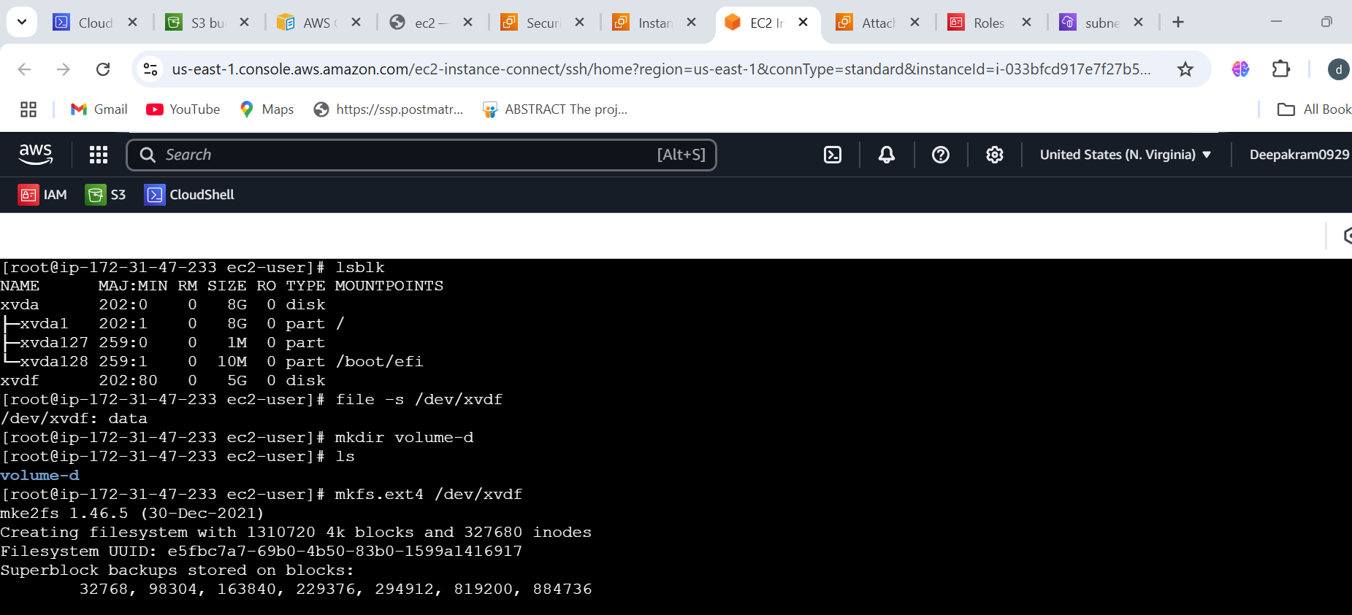

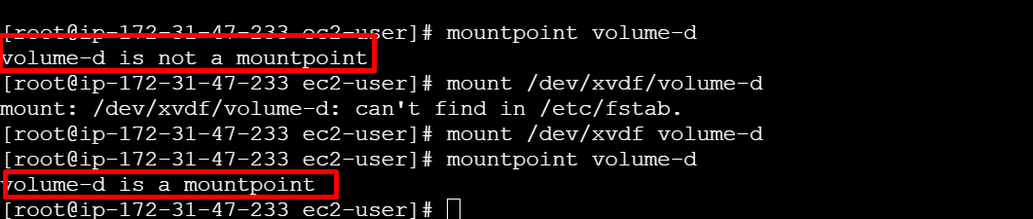

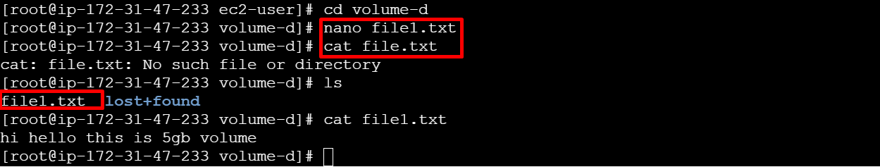

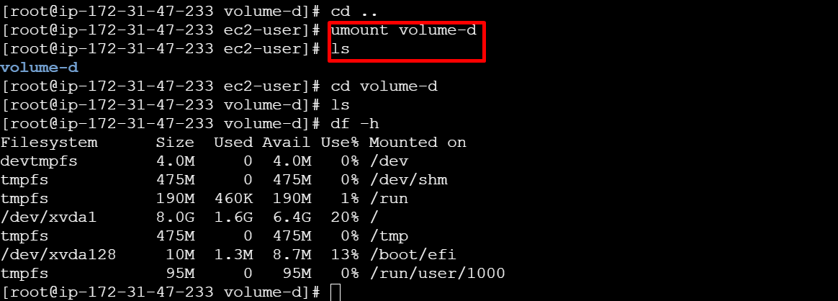

**To detach the volume**

aws ec2 detach-volume --volume-id vol-01ace7215e7239ea2

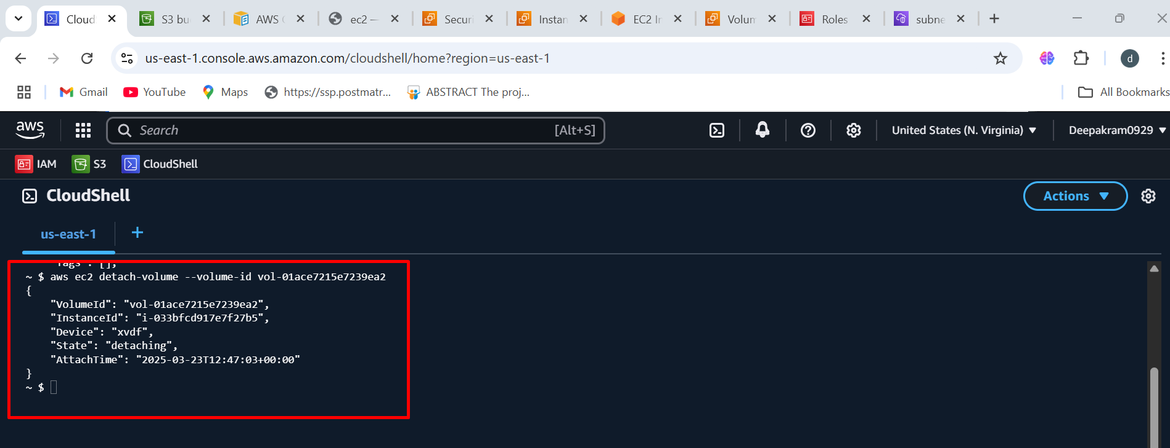

**After detaching check the volume state**

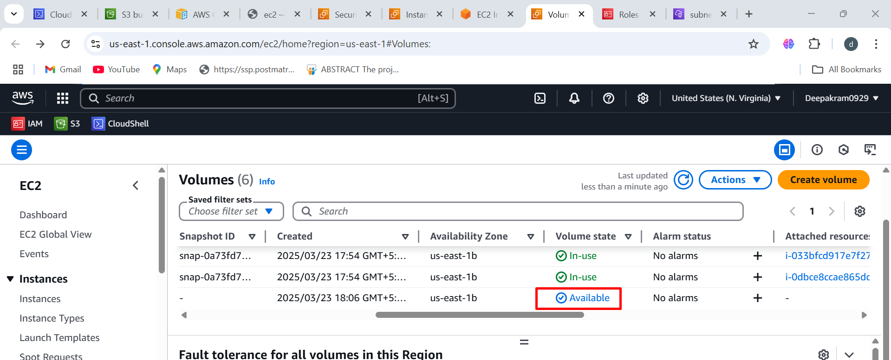

**TO STOP INSTANCES**

aws ec2 stop-instances --instance-ids i-033bfcd917e7f27b5 i-0dbce8ccae865dd1c i-09060d0cd34a577b0

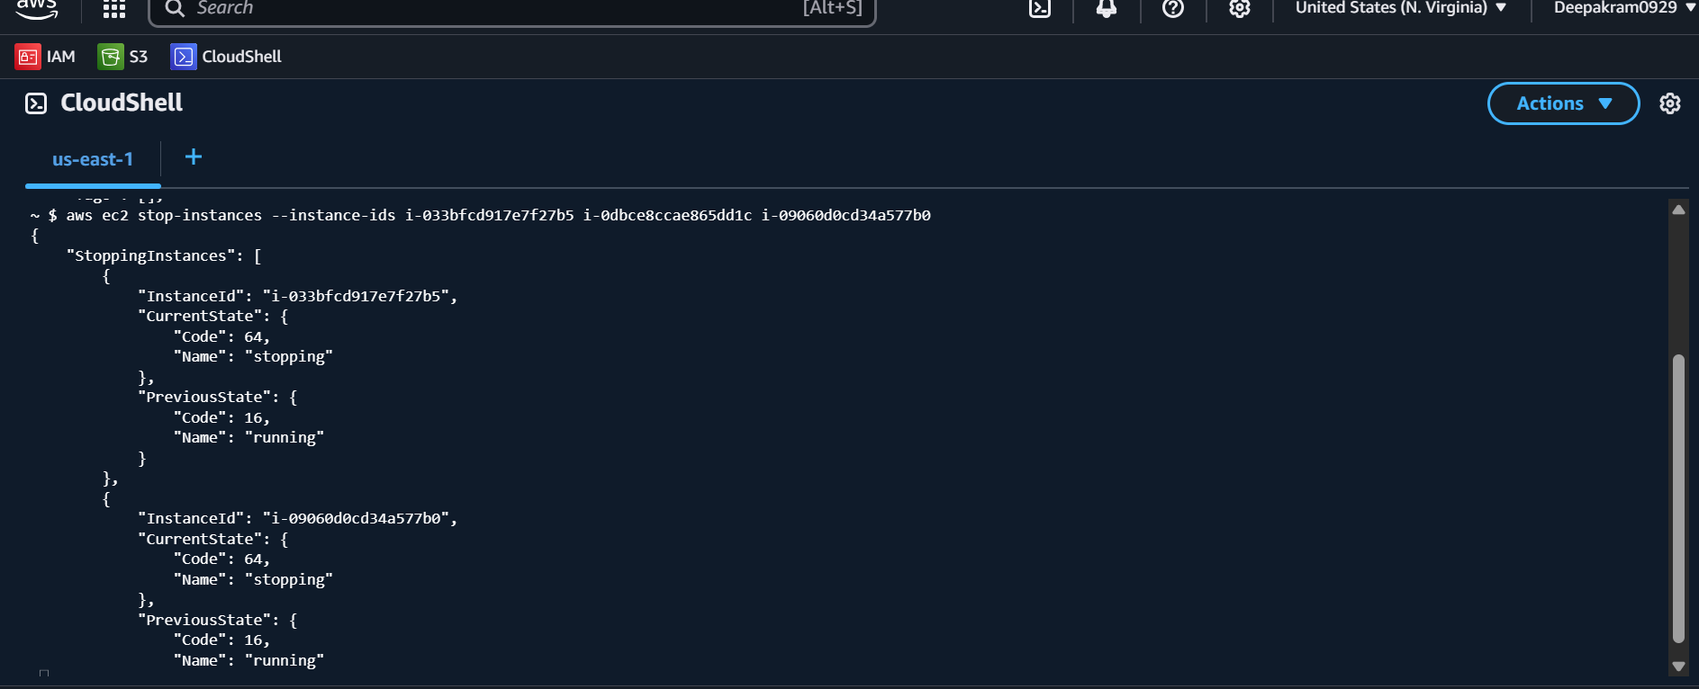

**TO DESCRIBE-INSTANCES**

aws ec2 describe-instances --instance-ids i-033bfcd917e7f27b5 i-0dbce8ccae865dd1c i-09060d0cd34a577b0

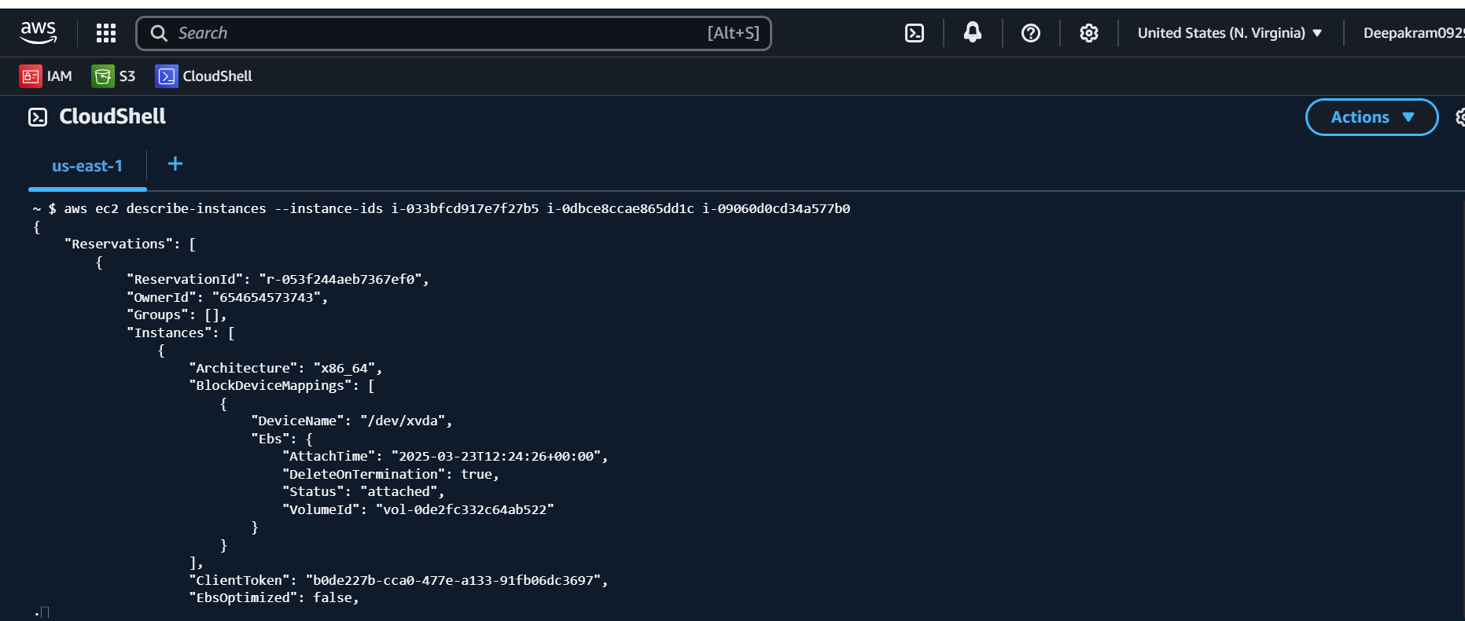

**TO TERMINATE-INSTANCES**

aws ec2 terminate-instances --instance-ids i-033bfcd917e7f27b5 i-0dbce8ccae865dd1c i-09060d0cd34a577b0

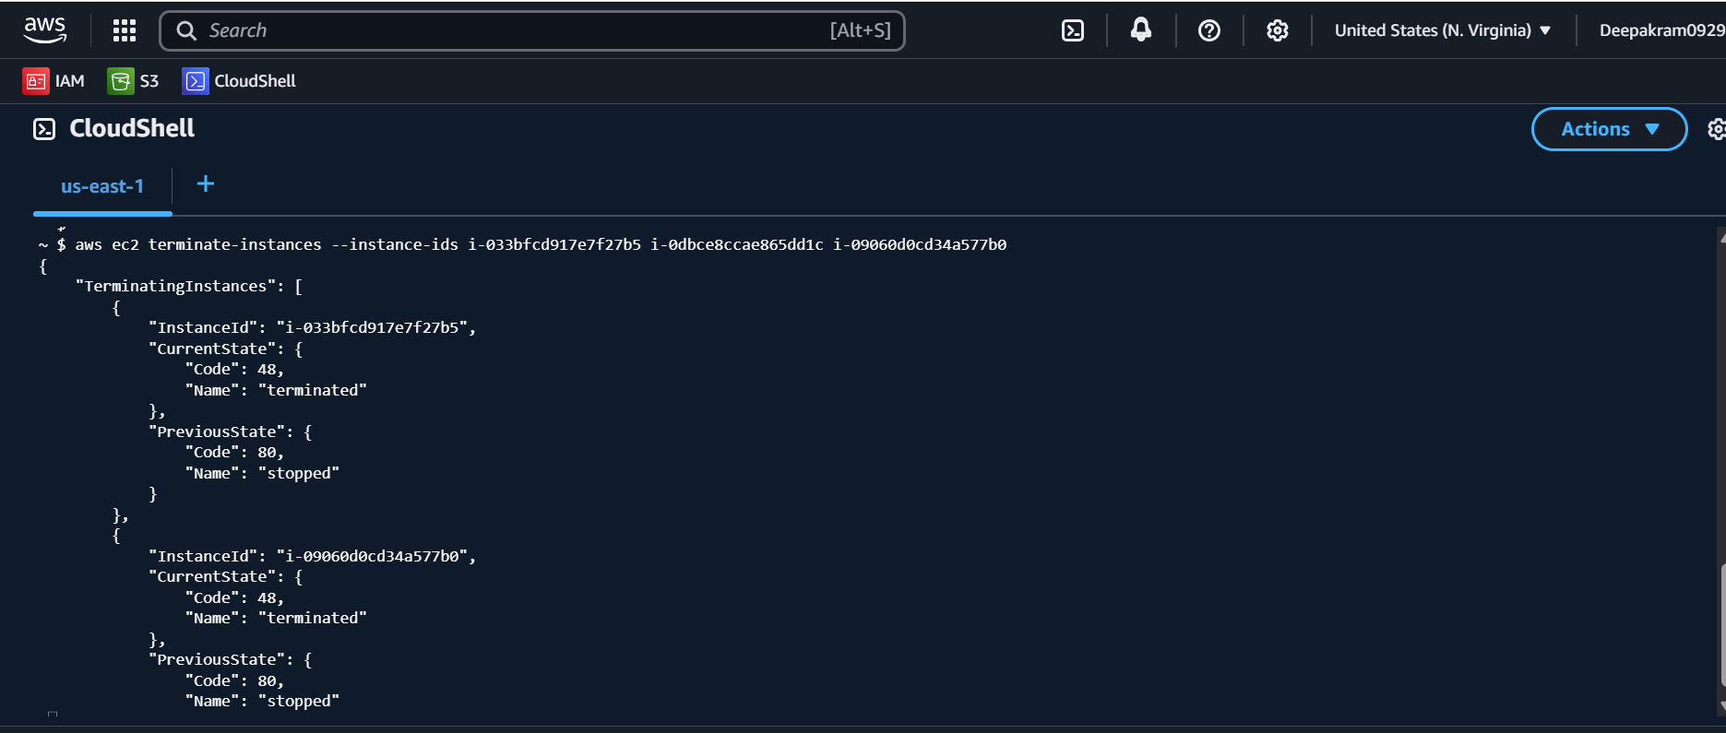

**TO START-INSTANCES**

aws ec2 start-instances --instance-ids i-0945c705e960f62d4

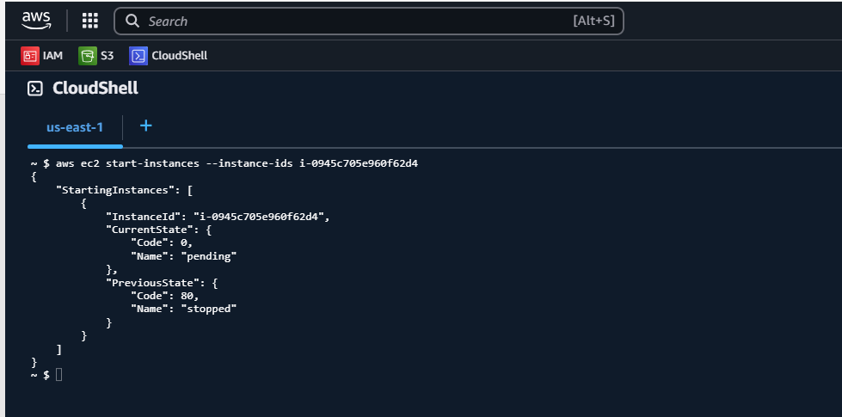

**TO LAUNCH EC2 WINDOWS INSTANCE**

**Commands:**

aws ec2 run-instances --image ami-02e3d076cbd5c28fa --instance-type t3.medium --key-name aws-key-0929 --security-group-ids sg-0b5b31eb64c1cb822 \

--subnet-id subnet-0936a2a3542bb45c1 --tag-specifications 'ResourceType=instance,Tags=[{Key=Name,Value=window-ser-1}]'

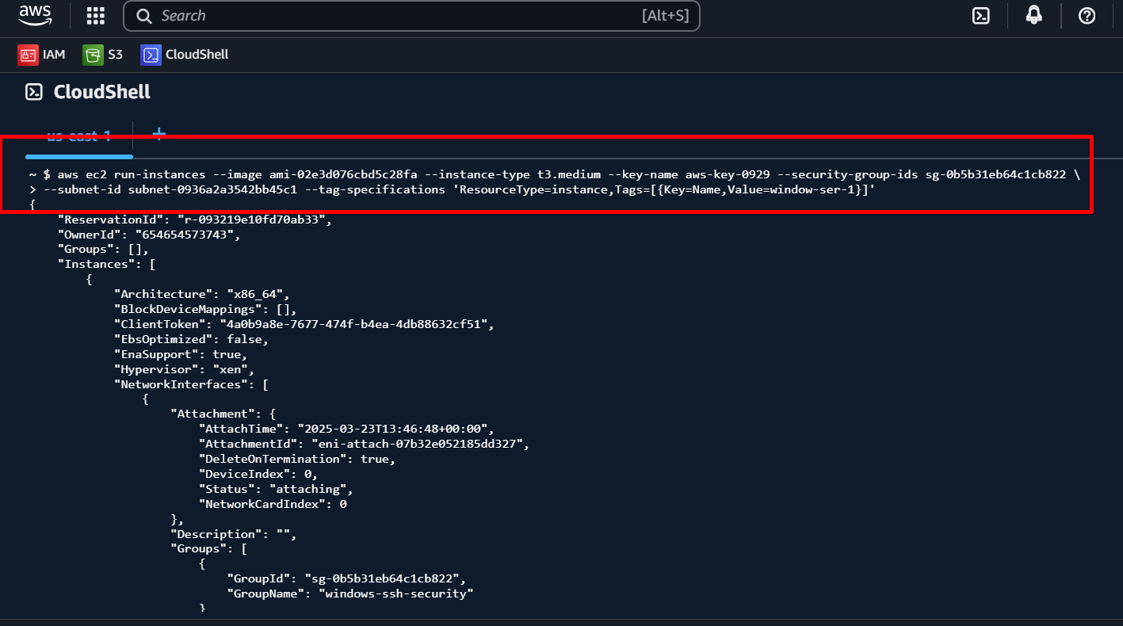

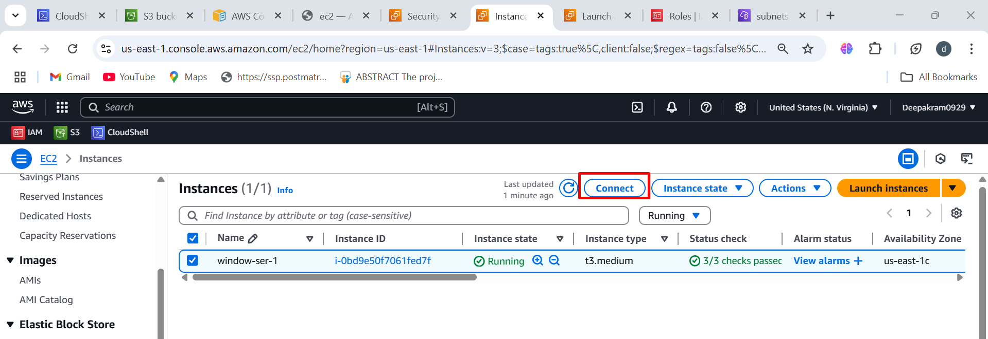

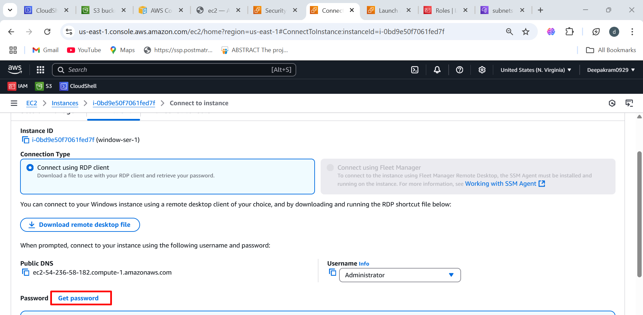

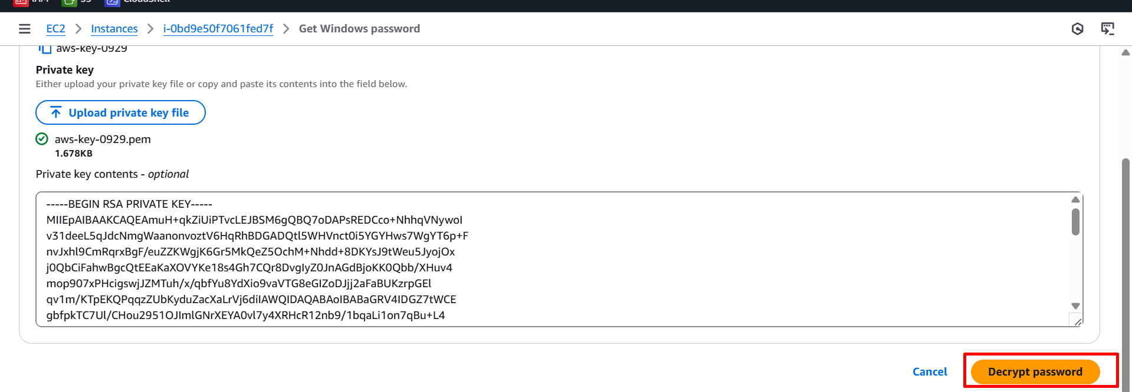

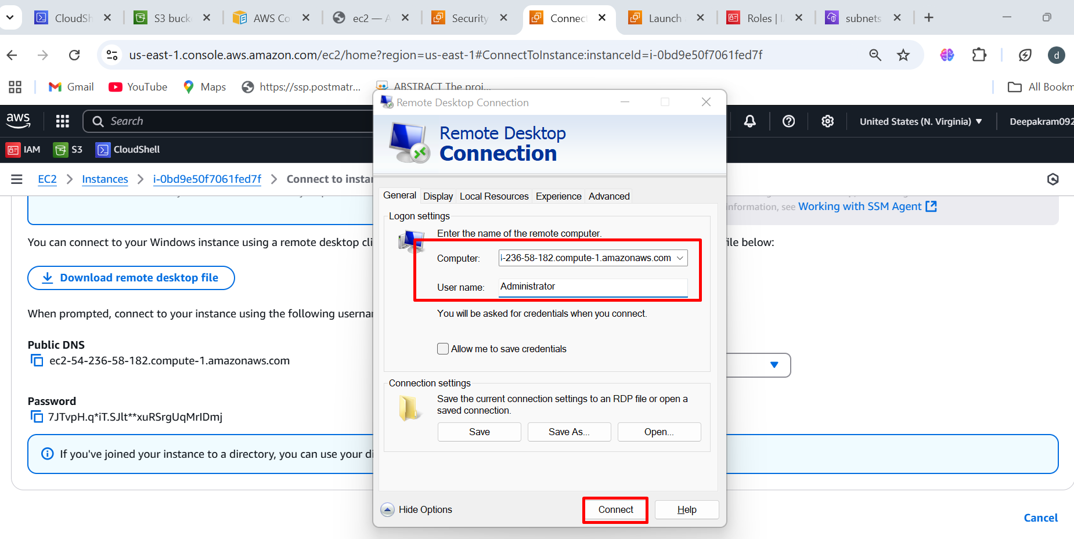

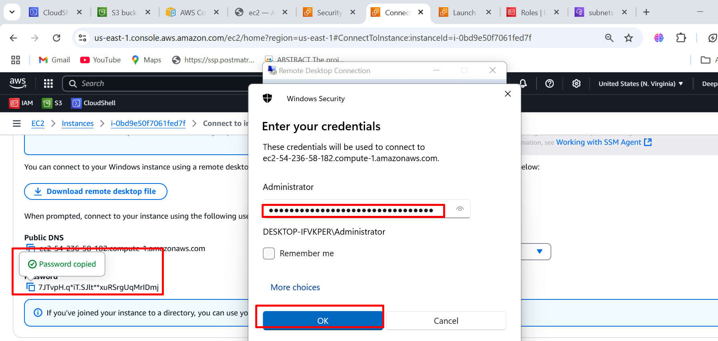

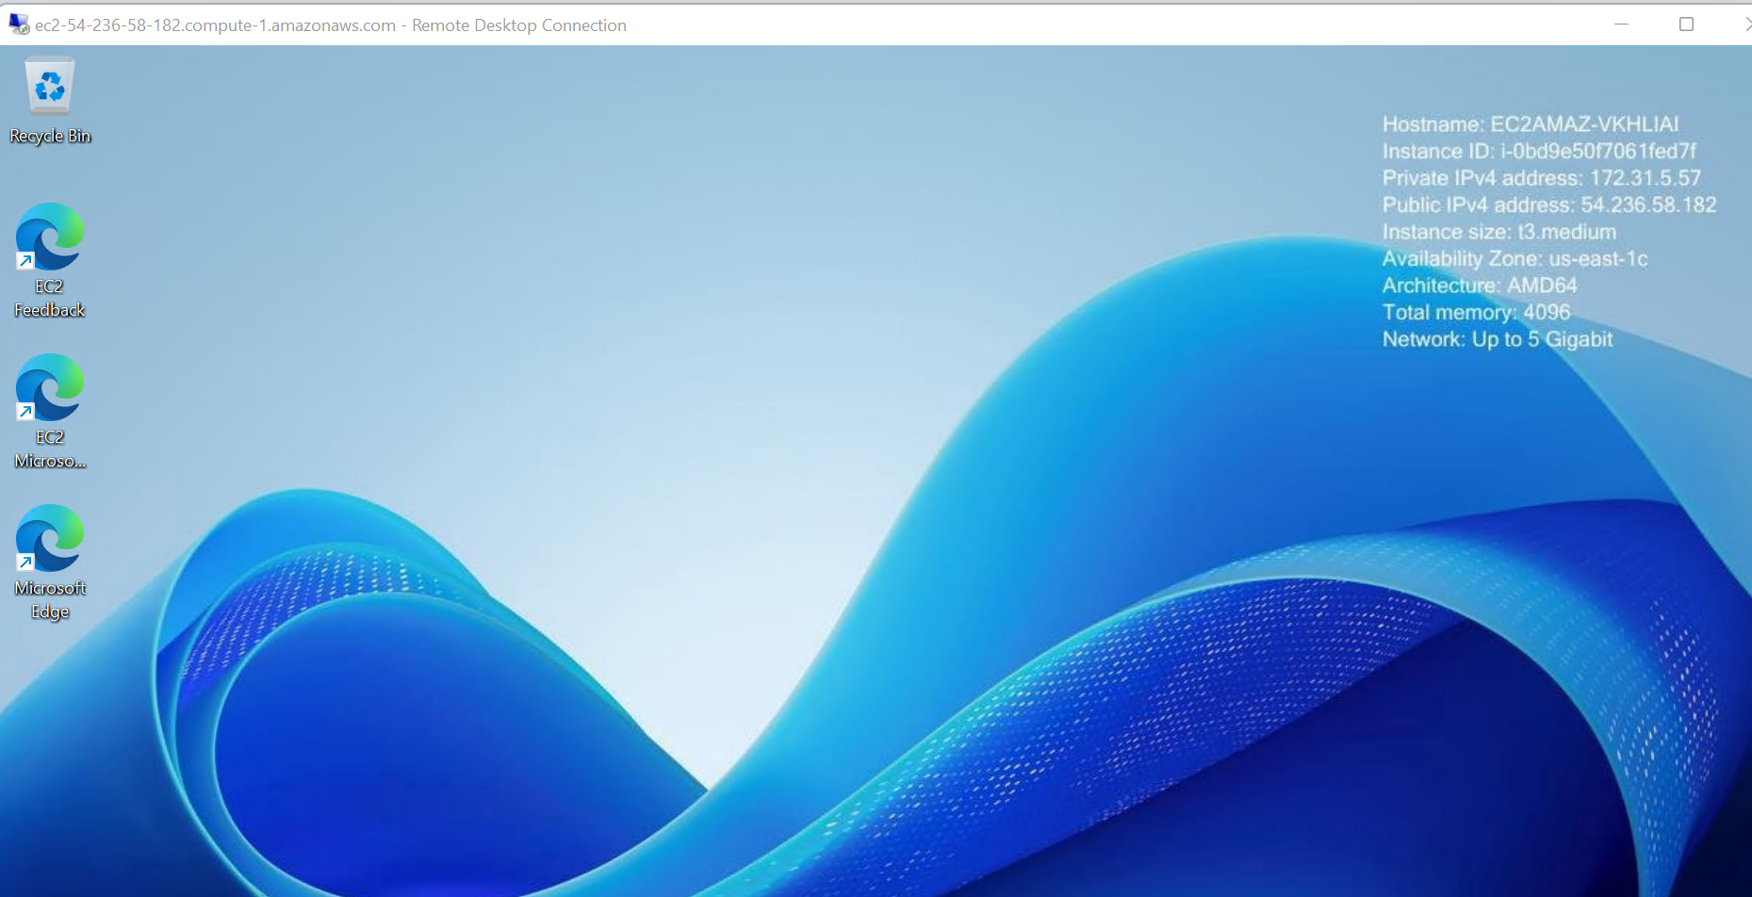

**To create snapshot**

aws ec2 create-snapshot --volume-id vol-01ace7215e7239ea2 --description "5gb snapshot"

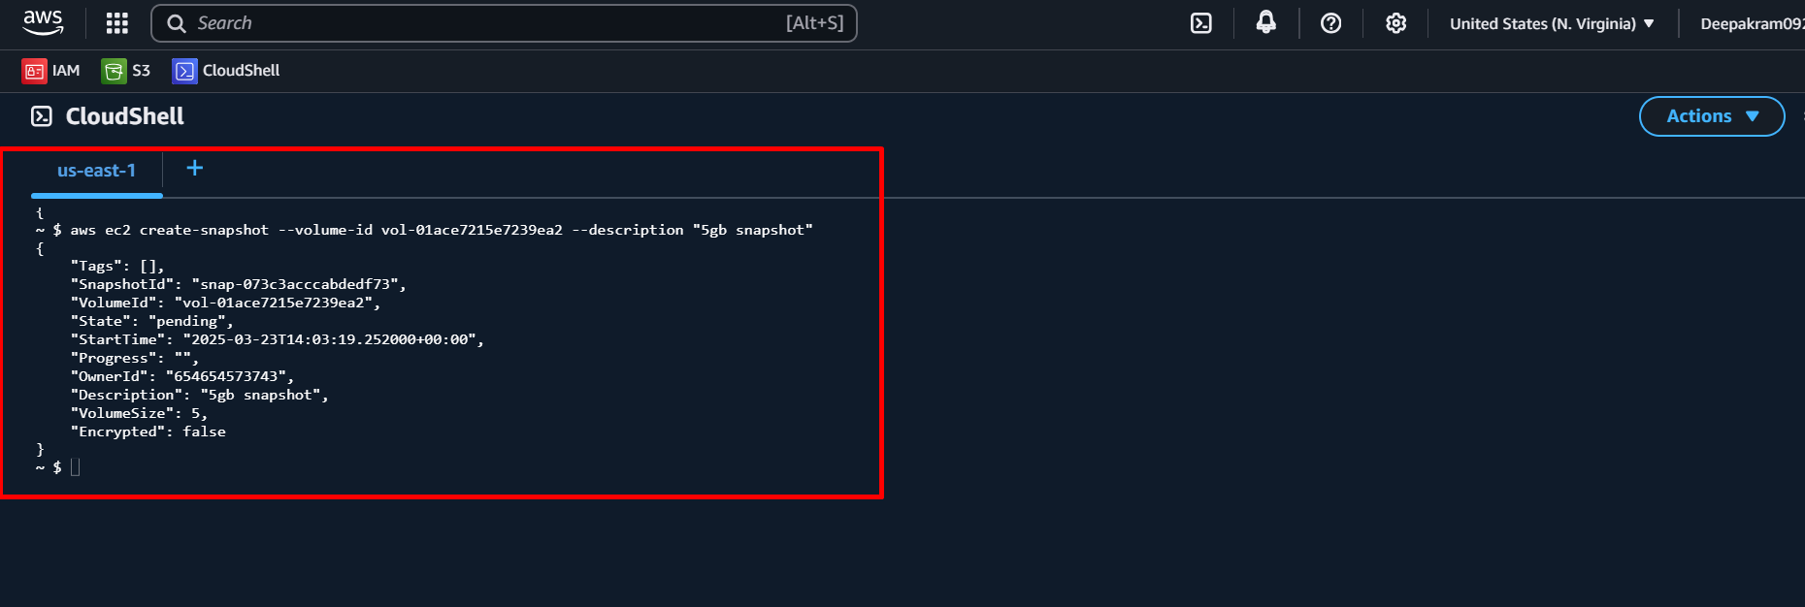

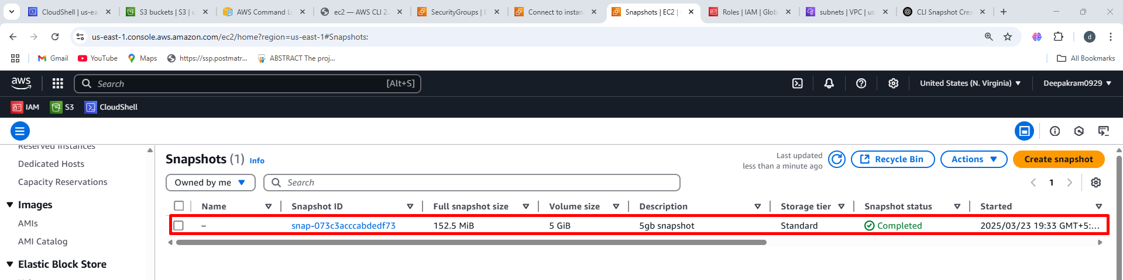

**CREATE VOLUME FROM SNAPSHOT**

aws ec2 create-volume --snapshot-id snap-073c3acccabdedf73 --availability-zone us-east-1c

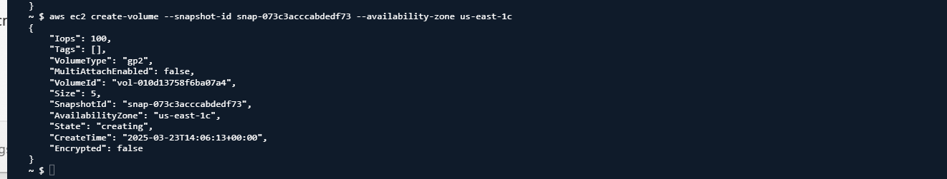

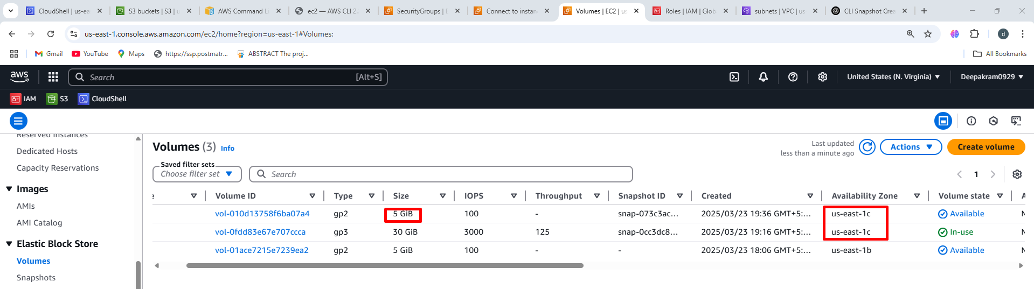

**THE VOLUME AS BEEN ATTACHED TO WINDOWS**

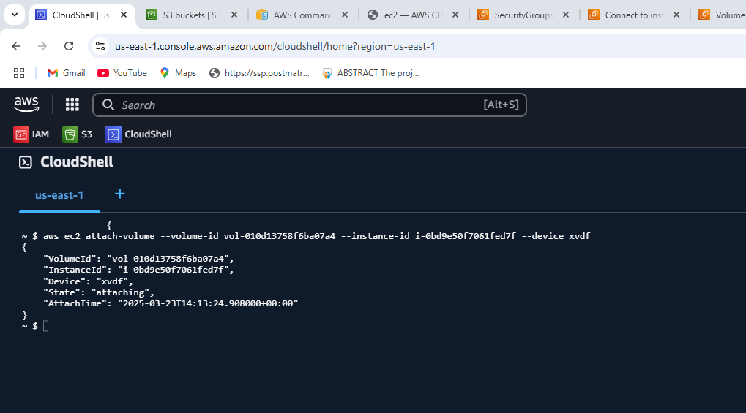

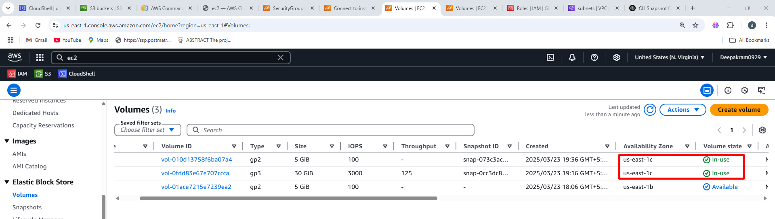

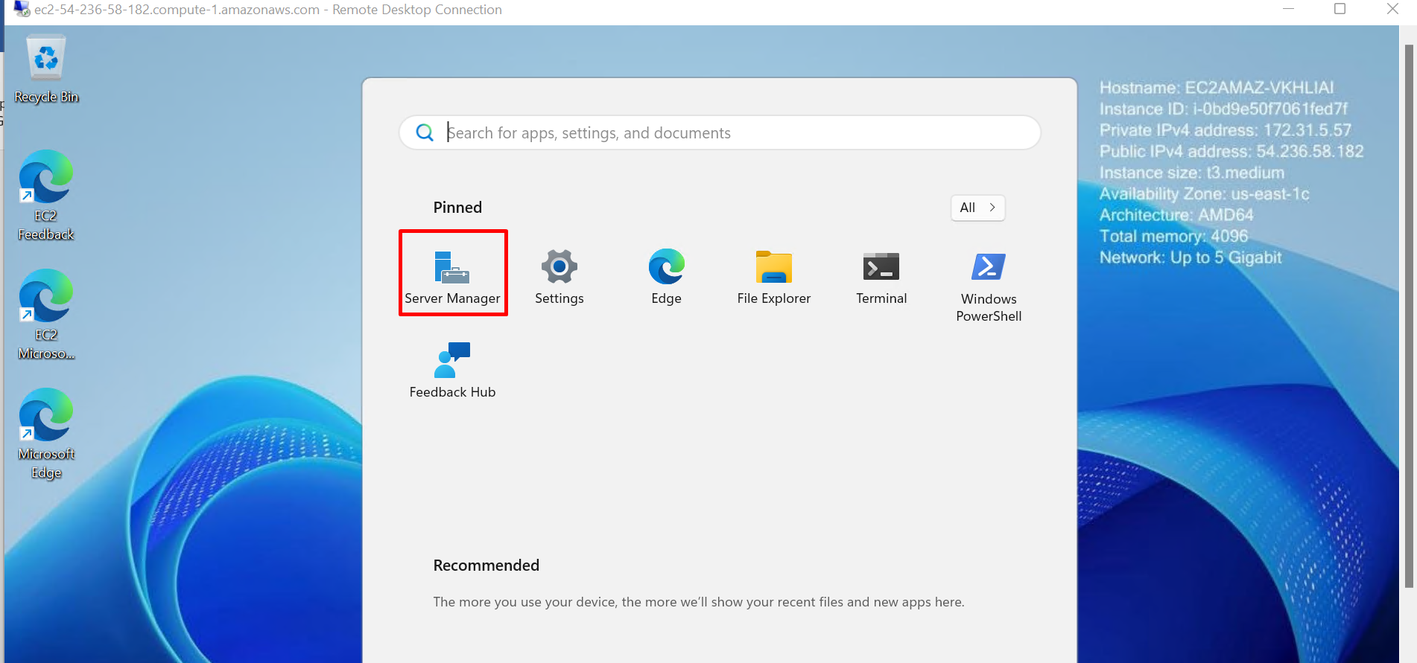

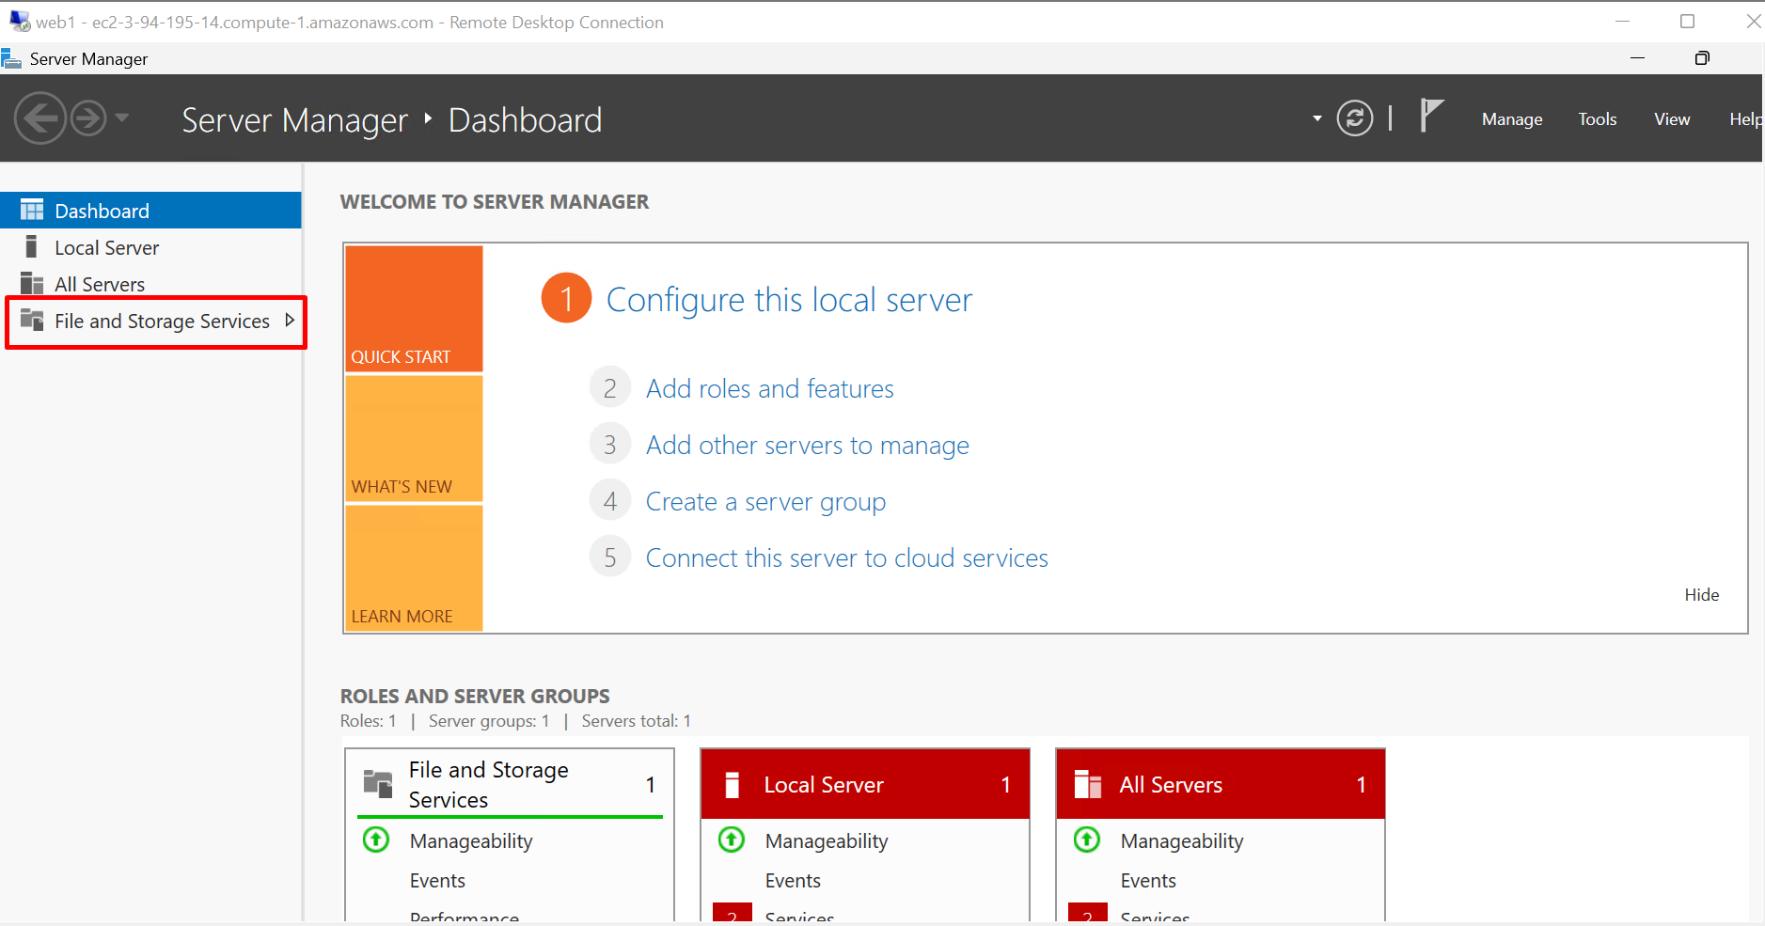

Locate the **5 GB disk** that is marked as **Unknown**. 🡪 Right-click the disk and select **Initialize Disk**.

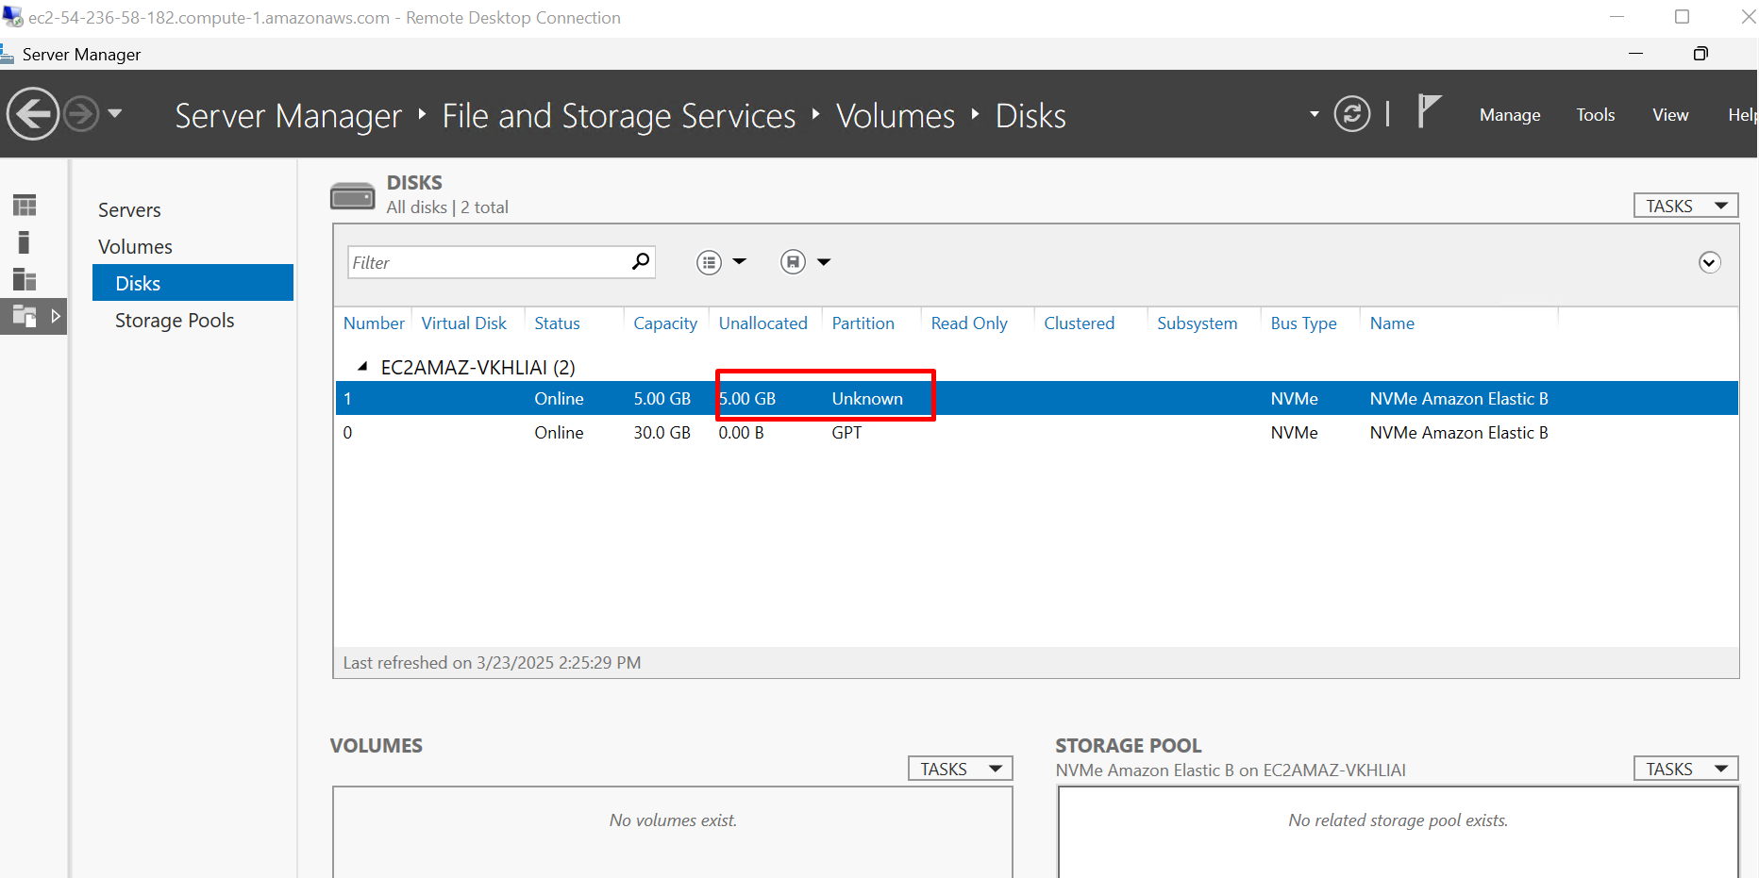

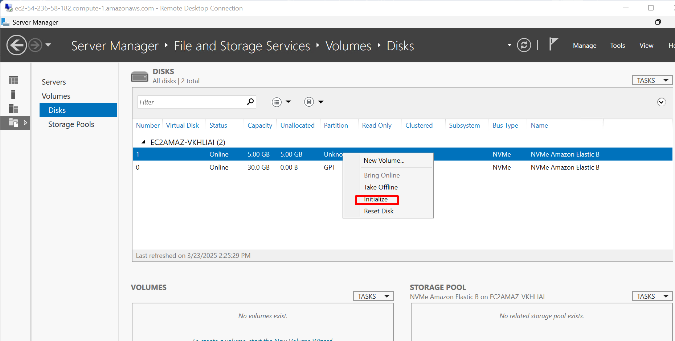

**GPT (GUID Partition Table)** 🡪 Recommended for modern Windows versions.

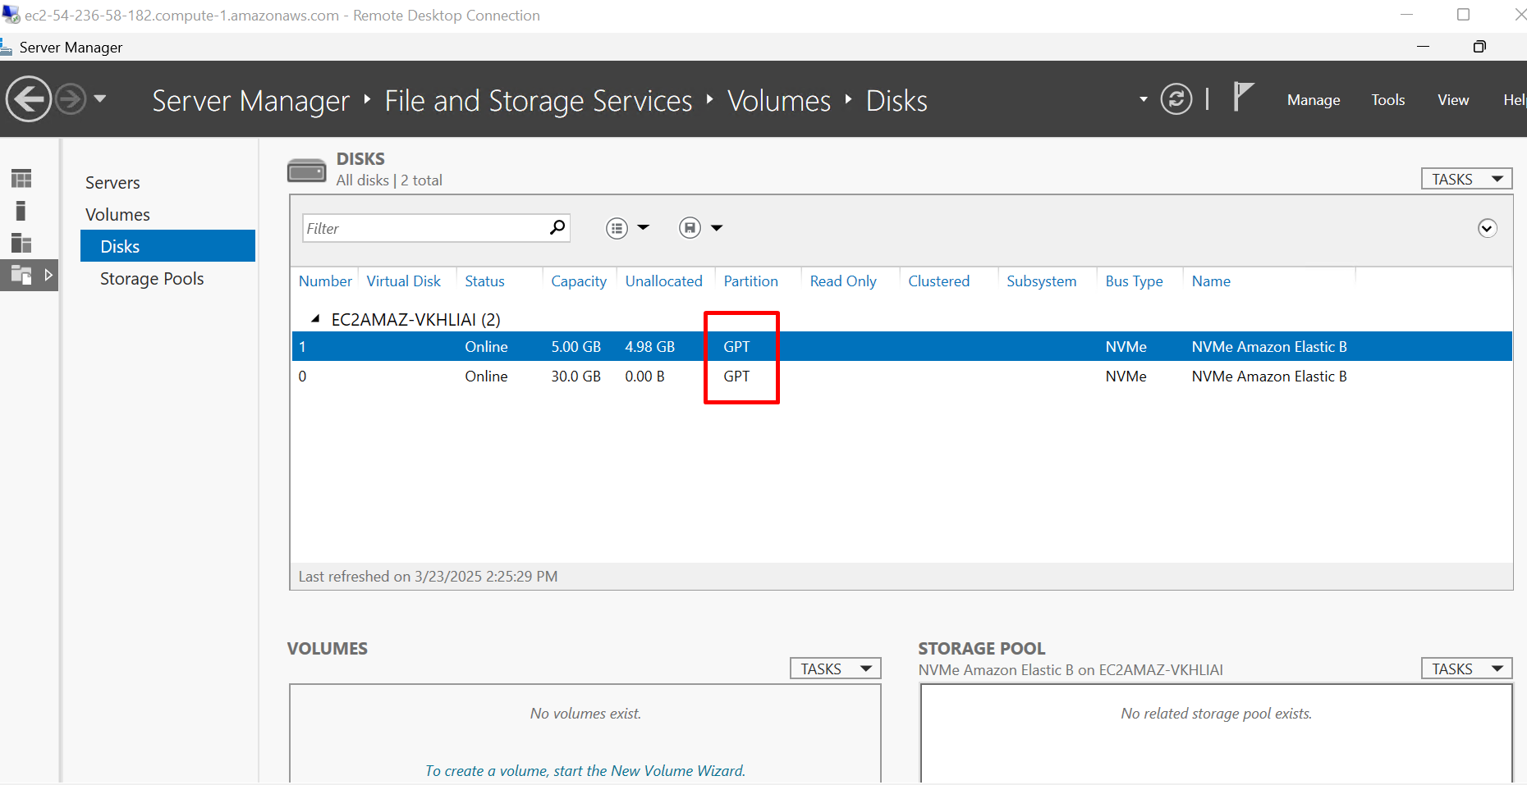

**Create a New Volume 🡪** Right-click the **Unallocated space** on the initialized disk.

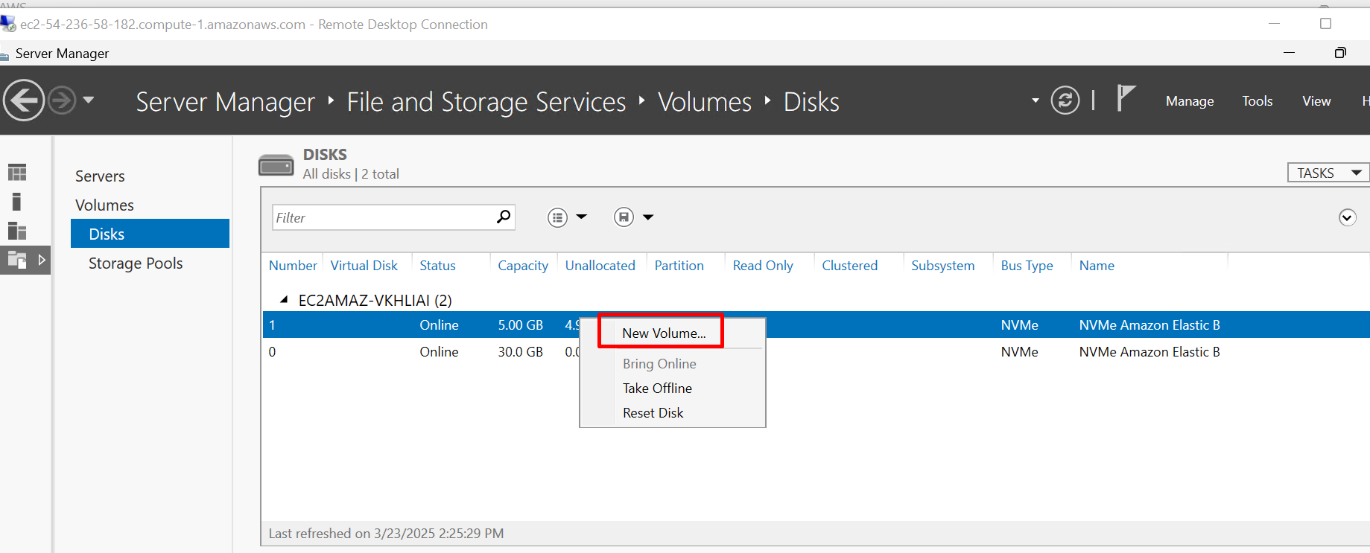

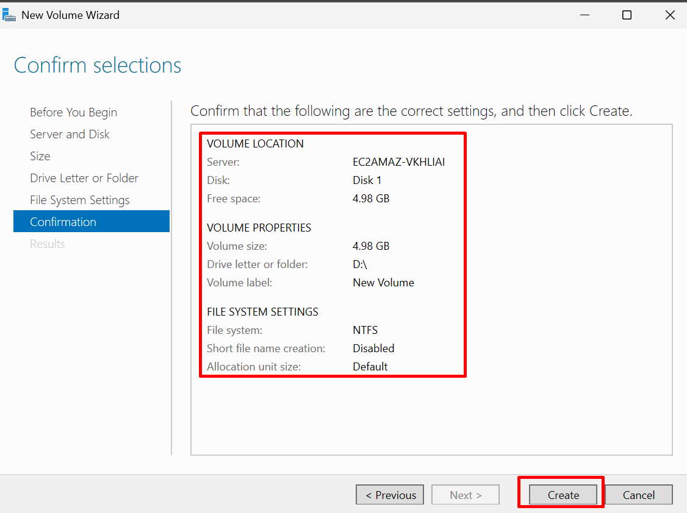

**Its shows a 5 GB Amazon Elastic Block Store (EBS) volume attached to an AWS EC2 instance running Windows Server.**

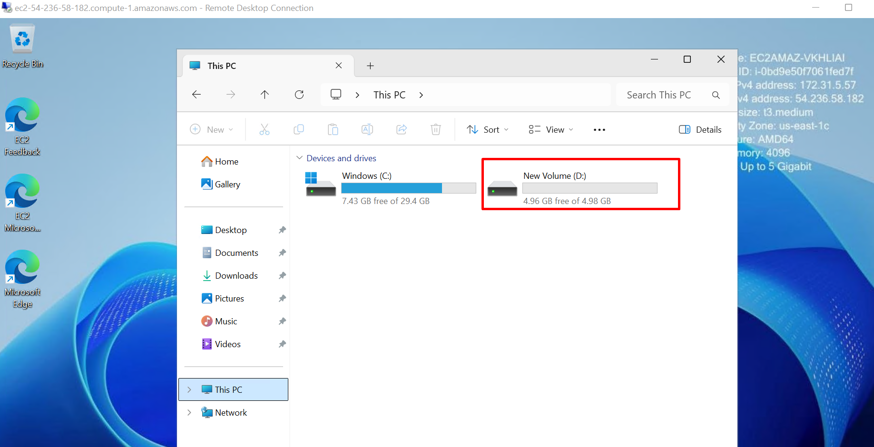

**TO DETACH EBS VOLUME**

**Cli commands :** aws ec2 detach-volume --volume-id vol-010d13758f6ba07a4

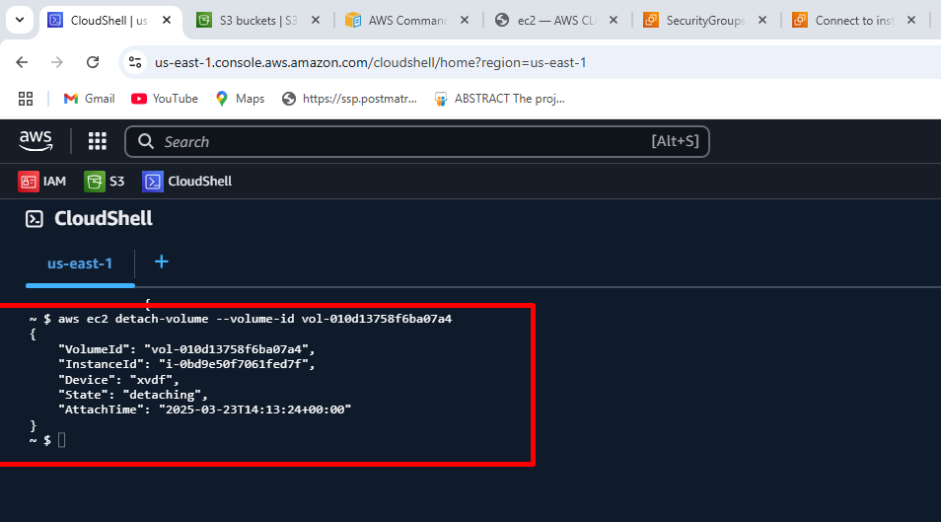

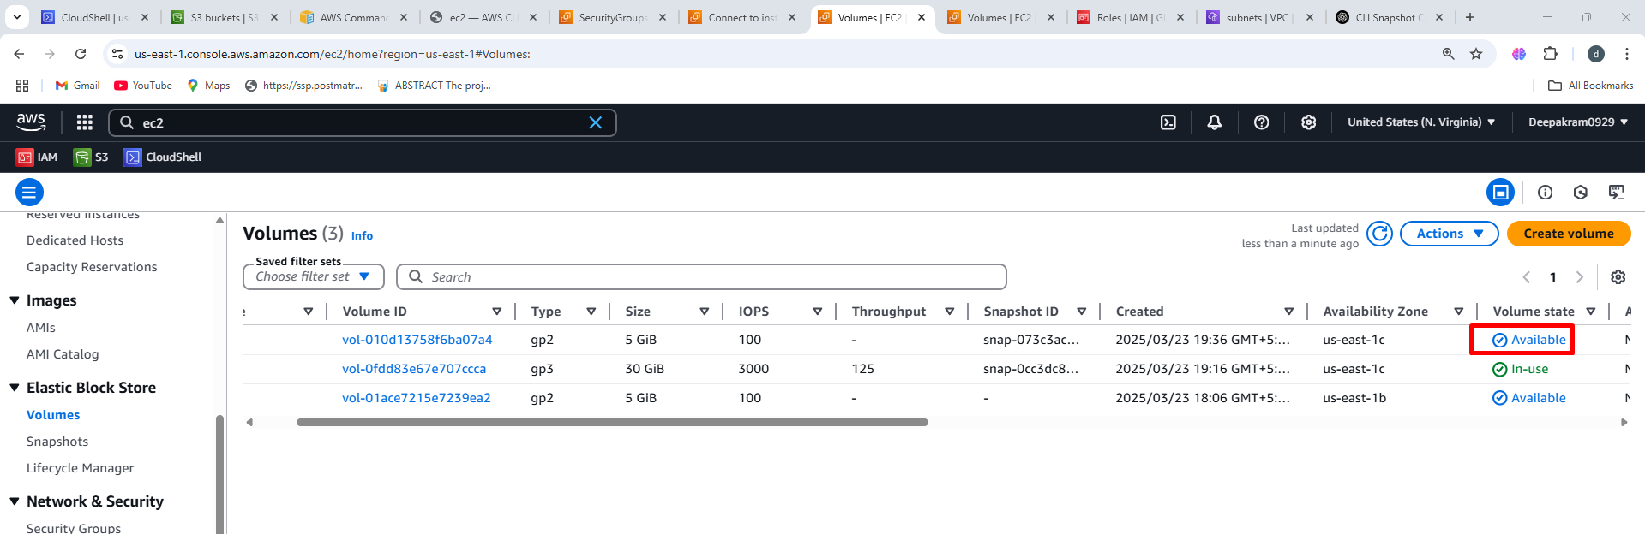

**TO TERMINATE INSTANCES**

aws ec2 terminate-instances --instance-ids i-0bd9e50f7061fed7f

